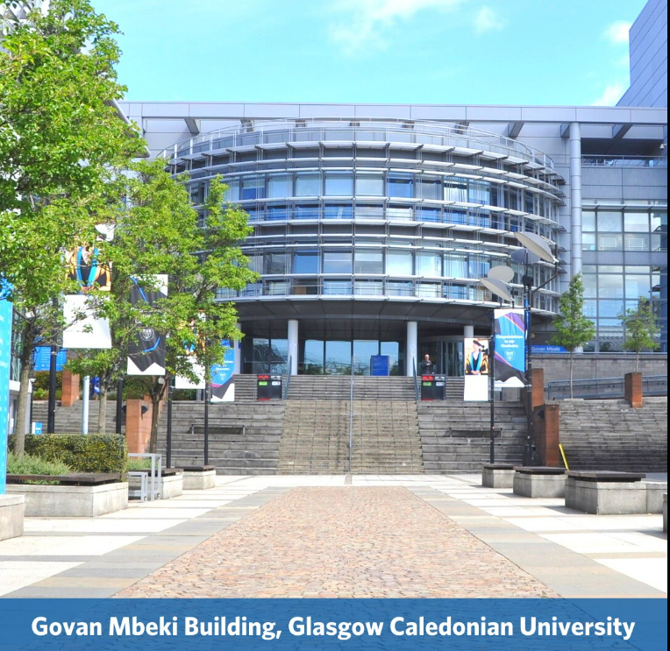

Clinical Tutor’s Day Friday, 17th May 2024

Deeprose Theatre, A005 Govan Mbeki Building

Programme

10.00 am Welcome and GCU Update – Claudine Wallace

10.15 am Sheffield Update – Professor Helen Davis

10.30 am UCL Update – Alice Donnachie

10.45 am Liverpool Update – Dr Jignasa Mehta

11.00 am Setting Standards: HCPC updates for Orthoptist Practice Educators – Fiona Campbell

11.30 am Clinical Tutor Forums “Tackling the issues together!” Michael Harmsworth

12.30 – 1.30 pm Lunch

1.30 pm HEE Clinical placement expansion project - Amrit Sehmi, Lucy Stafford and Debbie Steel

2.00 pm Orthoptic PrBL in Scotland - Exploring the use of simulation- Sarah Brown

2.30 pm Increasing capacity success story - Laura Wilson

2.45 pm How to read the allocation spreadsheet - Courtney Powdrill

3.00 pm Supporting students with Neurodiversity - GCU Disability team

3.30 pm Staff Well-Being – Lisa Gibson

3.45 pm Questions

4.00 pm Thank you and Close