**Orthoptics**

***Allied Health Professions Insight Day***

*Insert Date Here*





***Welcome…***

Today you will learn about the exciting career prospects orthoptics has to offer

You will:

* Learn how orthoptists apply their in-depth knowledge of the brain to a range of eye conditions
* Experience how visual problems impact our patients’ lives
* Try out orthoptic equipment we use every day

***Let’s get started…***

Explore the structures of the brain that are responsible for vision and eye movement

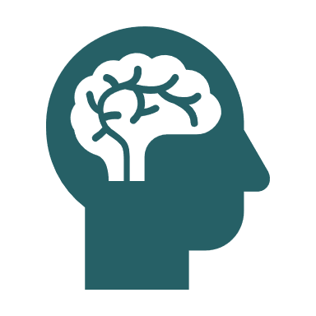

**Do you know how many eye muscles there are?**

**Orthoptists are experts in understanding neurological defects affecting how we see**

**The Brain Station**

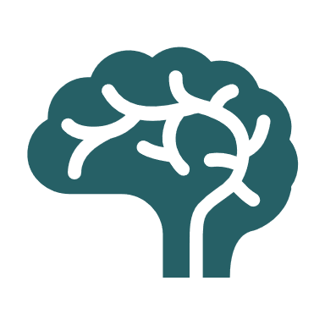

**THE specialists in how the eyes and brain work together**

**See how the cranial nerves travel through the brain to the muscles of the eyes**



Experience how a patient with a visual defect sees the world and the difficulties they may face

**Orthoptists are involved in the investigations prior to and after squint surgery**

**What daily tasks do you think would be more difficult for a patient with a vision problem?**



**Orthoptists prescribe patching, prisms and exercises to help relieve symptoms**

**Do you think orthoptists can have a positive impact on patients’ lives?**

Try using the orthoptic equipment

Do you know what these tests could be used for?



**Orthoptists can test vision in patients of all ages**

**Orthoptists can assess visual behaviour of nonverbal patients**

**Do you know how we would measure a squint/turn in the eye?**

**Can you find the prisms?**



**Many tests can be easily transported to schools and community clinics**

**Can you find a test for 3D vision?**

**The orthoptic term for this is stereopsis**