**MMedSci Ophthalmology Advanced Clinical Practice (Paediatrics)**

**The new three-year part-time Masters Course offered by The Division of Ophthalmology and Orthoptics at The University of Sheffield has begun! We have a great intake of students embarking on this important area of work and are thankful to BIOS for the student scholarships, which have helped make this possible.**

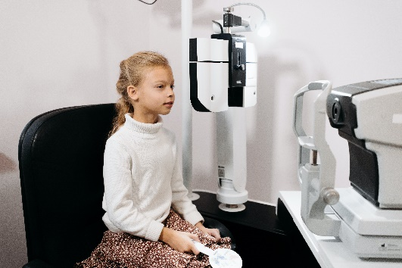

The course is suitable for:

* Current paediatric eye-care practitioners (Orthoptists, Optometrists and Ophthalmic Nurses) who want to advance their specialist ophthalmic practice skills.
* Professionals wishing to reach advanced clinical practitioner status in paediatric ophthalmology

**Course Description**

The course is an exciting opportunity for experienced eye-care practitioners to advance their specialist ophthalmic practice skills. The course facilitates a comprehensive and advanced knowledge of paediatric ophthalmology conditions, diagnostic expertise and management options. Teaching is mainly online, in addition to clinical work-based learning. Students need the support of a local mentor (paediatric ophthalmologist or ACP in paediatric ophthalmology) to complete the clinical aspects of the course.

The course encompasses the four pillars of advanced practice: clinical practice; facilitating learning; leadership; and evidence, research and development. The core 60 credit first year module includes an introduction to the role of the ACP in paediatric ophthalmology, diagnosing and managing blepharitis, dry eye, allergic conjunctivitis, juvenile idiopathic arthritis, inherited retinal disease, retinal imaging, electrodiagnostic testing, retinoscopy, glaucoma, contact lenses, investigative techniques, cerebral visual impairment, communicating with vision impaired children, disc and neurological screening, nasolacrimal duct obstruction, chalazion, surgical consent & surgical listing & emergency eye treatment and continued professional development. The second year encompasses a choice of modules from clinical leadership, research methods, low vision, medicines & concomitance & incomitance in depth, with the third year a choice between a clinical research project, or a literature based dissertation.

**Applications are now open for September 2022. To apply, please follow more links from our programme webpage:** <https://www.sheffield.ac.uk/postgraduate/taught/courses/2021/ophthalmology-advanced-clinical-practice-paediatrics-mmedsci-pg-certificate-pg-diploma>