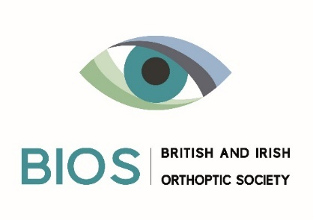
Orthoptic Education Fund
Application Form

1. Applicant’s details

Name:
Address:

Telephone:
Email:

BIOS Membership Number:

Place of work or study:

2. Grant details

a. Amount Requested

b. What will the grant be used for? (max. 150 words)

c. How will this grant advance the study or practice of orthoptics? (max. 150 words)

d. Have you made an application to any other organisation for funding?
Please provide details.

I have read the terms and conditions (available on the BIOS website) and if my application is successful, I agree to abide by them.

Signed: ______________________________________________

Date: ______________________________________________

Return application forms to oef@orthoptics.org.uk

