Approval guide for the creation of patient videos and use of the BIOS Portal
This Approval Guide has been developed to assist the Orthoptic Clinical Tutors in achieving Trust approval to use iPads to record patient assessments, and the centralised storage of these recordings on the BIOS Portal.

Version | Date created | Brief Summary of Change | Author/  Updated by
V1.1 | 27/01/2021 | Draft | M Murray
V1.2 | 28/01/2021 | Draft | M Murray
V1.3 | 29/01/2021 | Approved by Clinical Expansion Project Team and shared with Site Clinical Tutors via email. | M Murray
V1.4 | 22/02/2021 | Inclusion of BIOS Portal Disclaimer, Risk Log, Video Hosting Websites Information. | M Murray
V1.6 | 04/03/2021 | Updated workflows | M Murray
V1.7 | 10/03/2021 | Updated Workflows | M Murray
V1.8 | 11/03/2021 | Added DPIA and patient information to appendices | E Lomas
V1.9 | 07/04/2021 | Updated Workflows | E Lomas
V2.0 | 05/05/21 | Updated consent forms, Disclaimer, | A Donnachie
V2.1 | 21/6/21 | Updated consent forms, Disclaimer, PIL, security document, workflows, FAQs, Sharing Agreement, Best Practice Guidance and posters | E Lomas

Contents
1.0 - Overview of the project 5
1.1 - The Clinical Expansion Team 5
1.2 – Your Involvement 5
1.3 Project Team Meetings 5
2.0 - Who do you need to approach? 6
3.0 – Questionnaire for your initial meeting 6
4.0 - Documentation for Approval 6
5.0 - BIOS Portal information 7
6.0 - Appendices 8
Appendix A – Workflows 8
Appendix B – Benefits 14
Appendix C – Governance/Network Questionnaire 21
Appendix D – Supporting Documentation 23
Appendix F – BIOS Portal Disclaimer 59
Appendix G – Clinical Expansion Project Risk Log 61
Appendix H – Students University Disclaimers/Declarations 67
Appendix I – Video Hosting Website - Vimeo 68
Appendix J – Patient Information Leaflets (Adults) 71
Appendix K – Patient Information Leaflets (Paediatrics) 75
Appendix L - Consent forms (Adults) 79
Appendix M - Consent forms (Paeds) 85
appendix N – Sharing Agreement 90
Appendix O – Security Design 91
Appendix P- Frequently Asked Questions 99
Appendix Q – Waiting Room Posters 100
Appendix R – Best Practice Guidance 101

1.0 - Overview of the project
Following a successful bid to the Clinical Placement Expansion fund, BIOS was awarded £90,000 to enable expansion of clinical placement provision. This is a fantastic opportunity to develop a bespoke portal of video resources that will augment clinical experience, allowing students to continue to develop their clinical reasoning and decision making skills, at times when clinical placement capacity may be limited. This will be of particular benefit now in reaction to the COVID-19 Pandemic, however; an additional aim is for this project to provide a legacy of resource, that will be available for many years to come.

1.1 - The Clinical Expansion Team
A team has been identified to work on the development of this project, the team includes:
- Technical Support Role – Michelle Murray (contracted 6 months from December 2020)
- BIOS Lead Clinical Tutor – Elizabeth Lomas and Alice Donnachie (9 month secondment).
If you have any questions concerning the implementation of this project please contact the team at clinicaleducation@orthoptics.org.uk
The Clinical Expansion Team is currently working with the appropriate stakeholders in order to design and document the necessary processes required for the implementation of the BIOS portal and creation of patient videos. Additional detail regarding intended workflows can be viewed in Appendix A.

1.2 – Your Involvement
Your Trust has been identified as a potential site to aid in the creation of patient videos for the new BIOS learning portal. These recordings should be made on a departmental iPad, and BIOS has secured some funding to provide these if you do not have access to one already. Any videos or photographs which you create can then be submitted to the BIOS portal, and once they have been edited by the BIOS Lead Clinical Tutors, will be accessible by students at all four Orthoptic University courses in the UK.

1.3 Project Team Meetings
Attendance at the Clinical Expansion Project Team Meetings is crucial to the success of this project. The Clinical Expansion Team are here to work with each site, in order to develop supporting materials required to obtain individual Trust approval and to track the progress of each site to ensure readiness for any approaching project ‘go live’ dates. These meetings will also be an opportunity for sites to collaborate and share any information which may be useful to other clinical sites in obtaining Trust approval.
Although the project has been developed specifically to support Orthoptics students, it represents many potential benefits for the clinical tutors, departments and trusts involved. For additional information on the intended benefits of the project – please see Appendix B.

2.0 - Who do you need to approach?
You should discuss the project and your site involvement with your direct line manager/Head Orthoptist to ensure you have their support.
Speak to other members of staff within your department who are involved in clinical teaching – this will need to be a team effort!
Creating and sharing patient videos for teaching purposes will need to be approved by your Trust, as it has several data protection implications. Make contact with the following/equivalent people within your trust to determine who you will need to involve in the project:
- Business Support Manager
- Information Governance Manager
- DSP (Data Security and Protection) Facilitator
- Head of Data, Security, and Protection.
- IT / Network Team

3.0 – Questionnaire for your initial meeting
Although your initial meeting with the trust will be an opportunity for you to introduce the project, outline the intended workflows and describe the intended benefits – it is also an opportunity to identify any constraints/limitations within your organisation which need to be addressed at the start of this project. Please refer to Appendix C for the Governance/Network Questionnaire that you will need to complete with both your Information Governance/Data Security department and your IT/Network Team. Please provide as much detail on the form as possible and send the completed forms to clinicaleducation@orthoptics.org.uk
It is likely that your trust will have a number of questions for you – if you are unable to answer them using the information provided in this catalogue, please feel free to note these questions on the Governance/Network Questionnaire and we will aim to respond to all queries.

4.0 - Documentation for Approval
Following your initial meeting, it is likely that you will be required to complete a selection of documentation specific to your trust, to satisfy their data protection requirements. Below is a list of possible documentation that you may be asked to complete (see Appendix E for further information). Although these documents may differ slightly from your trust specific documentation, please use them as a guide. If you are required to provide additional documentation or require any assistance/further information in order to be able to complete any of your trust specific documents, please contact the Clinical Expansion Team.
- DPIA (Data Protection Impact Assessment) attached
- Project Implementation Plan
- Risk Register
- Data security and protection assessment for external parties.
- Patient information Leaflets (adult and child)
- Consent form
- Disclaimers (for the BIOS portal and those completed by students for live viewings at University)

5.0 - BIOS Portal information
The BIOS Portal is a website that is currently being designed by Douglas Digital to enable the centralised storage of all recorded patient assessments. Your trust is likely to require information on the features and data/security credentials of the BIOS Portal. The Clinical Expansion Team is currently working with Douglas Digital to document the following security features of the portal. Once this information has been confirmed, it will be documented in Appendix F and the Project Team will be notified.
- Separate areas for students and clinicians – to enable specific content to be restricted i.e. consent database.
- Prompt all registered members of the BIOS Portal to sign a declaration to remind them of the terms and conditions.
- Restricted ability to download content and only allow the video content to be streamed.
- Audit trail to monitor the users who accessed the content
- Awaiting information on the server to be used to store the video content i.e. where the server will be located, the security in place to protect the data.

6.0 - Appendices

Appendix A – Workflows
Please note – These workflows are in a DRAFT format. The red text boxes represent processes that still need to be finalised.

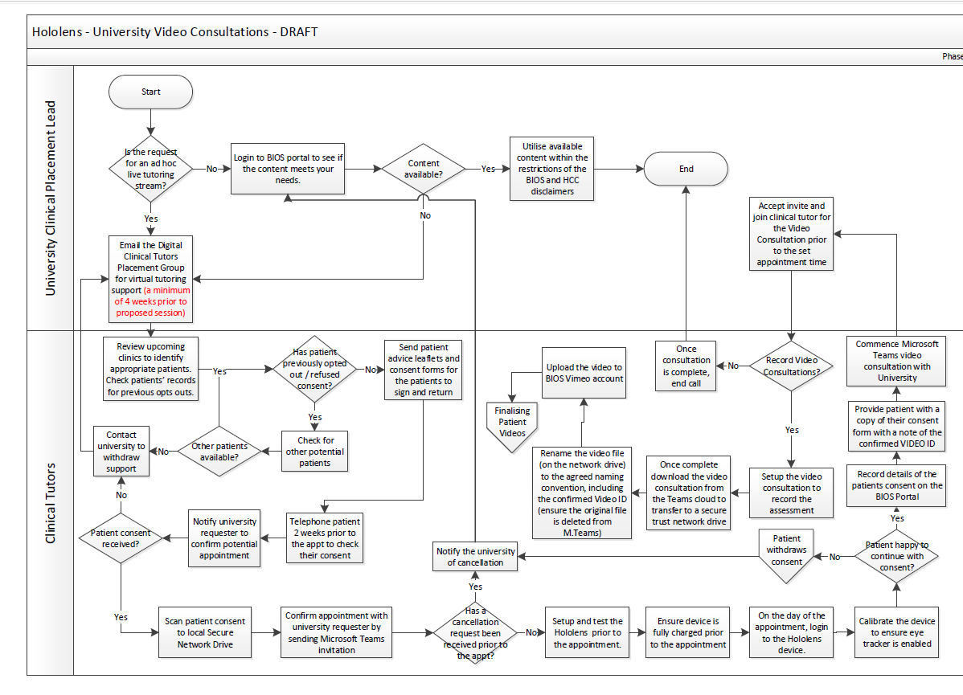
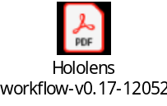
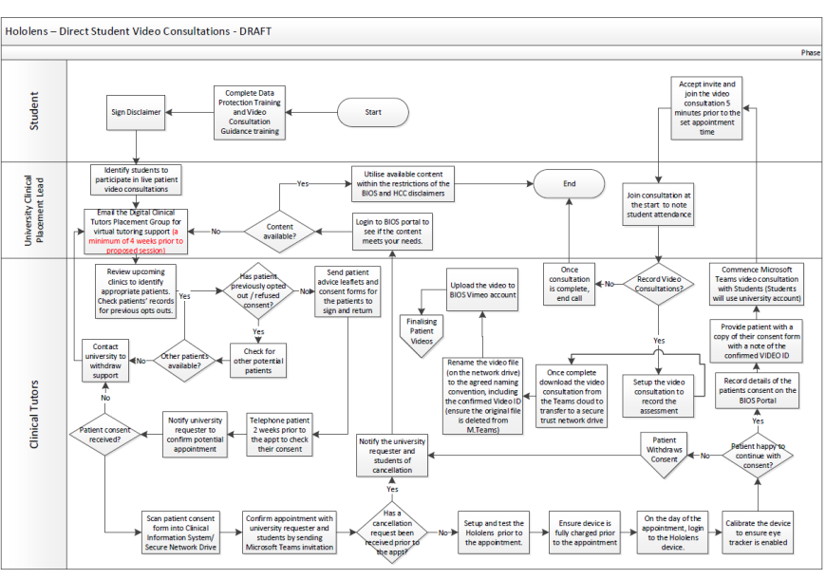

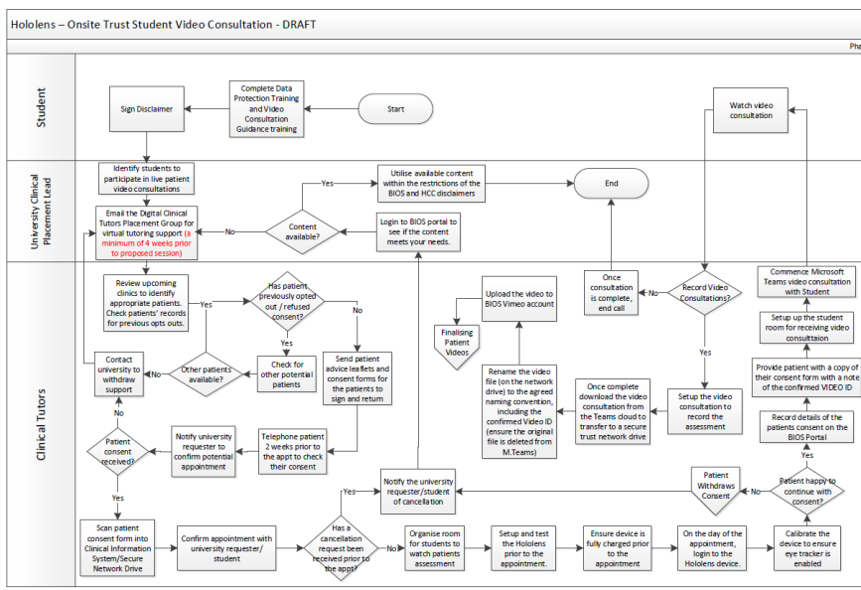

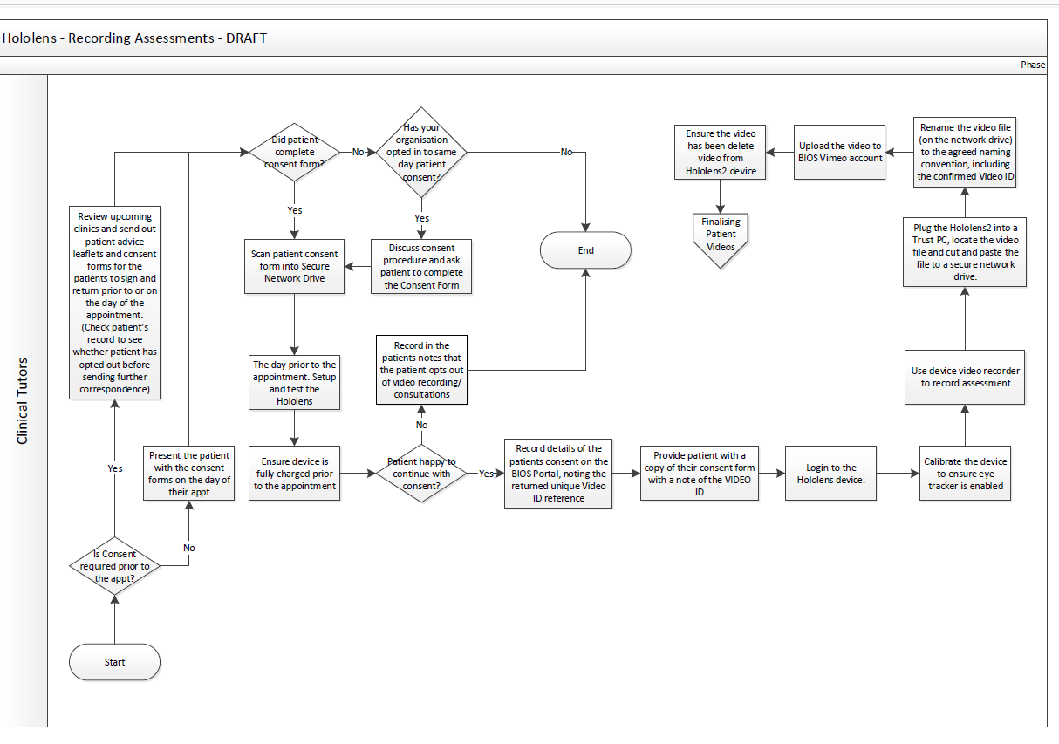

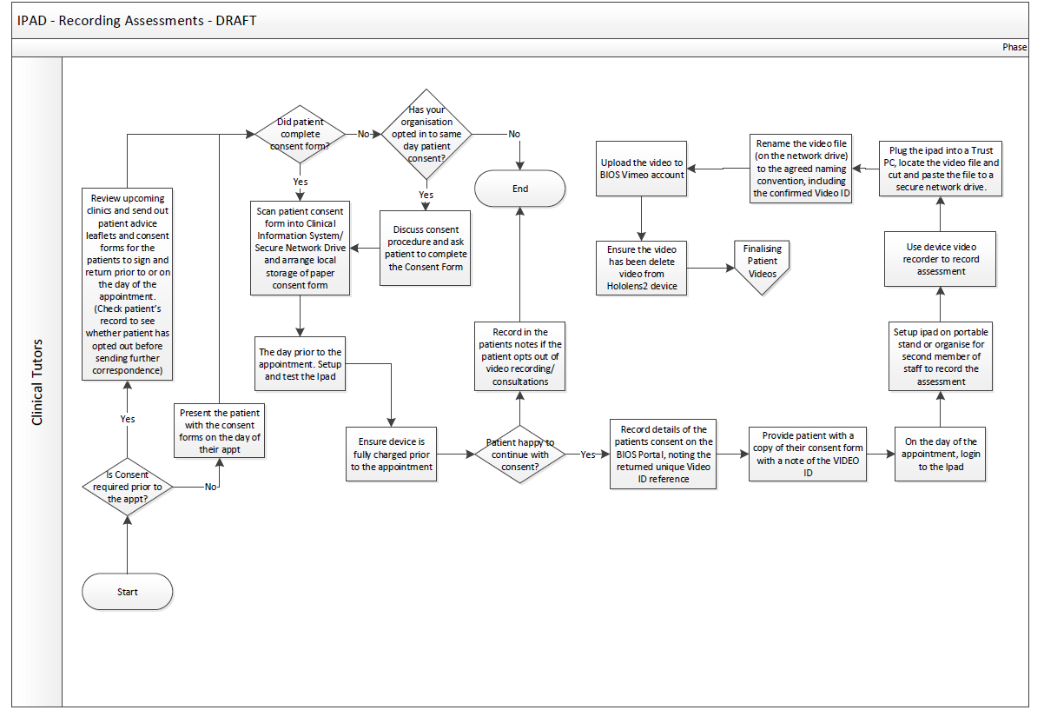
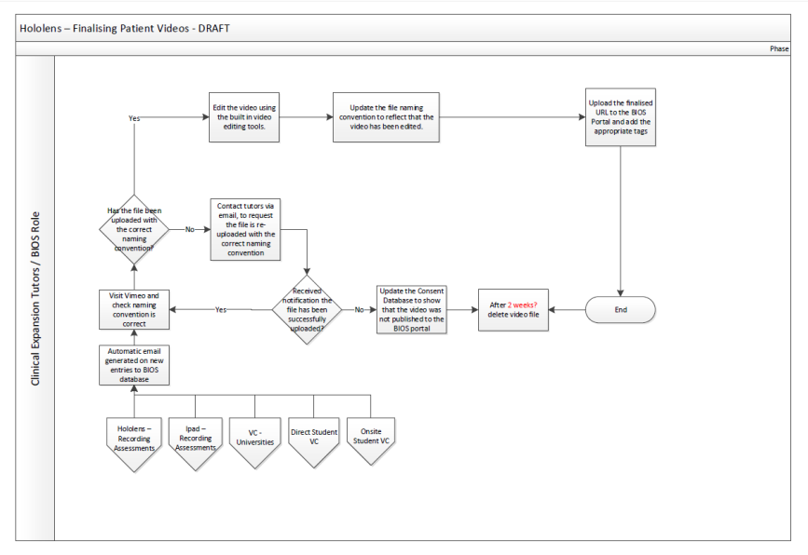
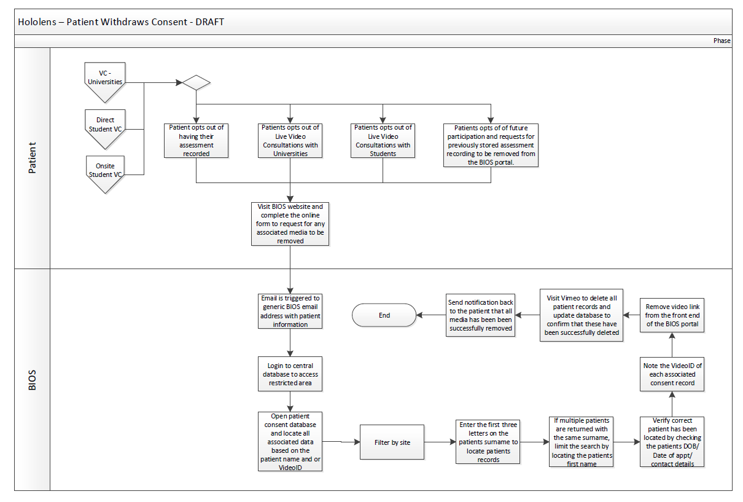

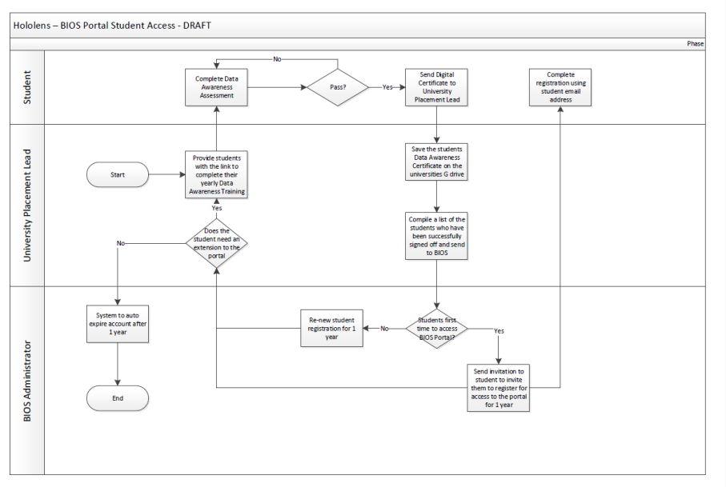

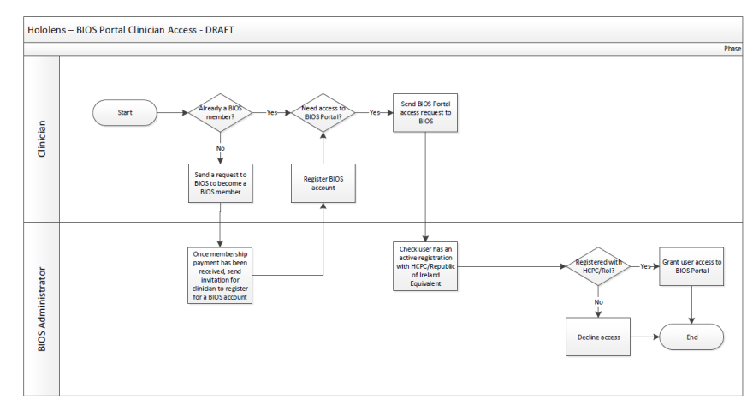

Appendix B – Benefits
Benefit Ref# |  |  |  |  | How can it will be Measured | Baseline | Proposed Improvement | Type of Benefit | Benefit Start Date
Benefit Ref# |  |  |  |  | How can it will be Measured | Baseline | Proposed Improvement | Quality Improvement | Benefit Start Date
Benefit Ref# | Identified By | Benefits Name | Benefit Description | Stakeholders Affected | How can it will be Measured | Baseline | Proposed Improvement | Performance | Benefit Start Date
Benefit Ref# |  |  |  |  | How can it will be Measured | Baseline | Proposed Improvement | Patient/Staff Experience | Benefit Start Date
Benefit Ref# |  |  |  |  | How can it will be Measured | Baseline | Proposed Improvement | Financial | Benefit Start Date
Ben001 | Michelle Murray | Students Contact | Students will have increased face to face access to patients | Students | Clinical portfolios | Clinical placement opportunities before the Hololens project was implemented | Increased frequency of patient focused learning opportunities. | Quality Improvement | 01/06/2021
Ben002 | Michelle Murray | Enhanced Teaching | Increased learning opportunities for students with augmented clinical education | Students | Student satisfaction and feedback. Clinical competency as assessed on clinical placement and through University examinations. | Clinical education opportunities (without augmentation) before the Hololens project was implemented | Augmentation of clinical experiences to allow maximum understanding and knowledge retention | Quality Improvement | 01/06/2021
Ben003 | Michelle Murray | Reduced Pressure on Placement Sites | Reduce pressure on hospital clinical tutors, as potentially they wouldn't have as many students onsite at any one time. | Clinical Tutors | Clinical Tutor feedback. Placement co-ordinator feedback. Frequency of cancelled placements | Clinical placement opportunies before the Hololens project was implemented | Reduce pressure on hospital clinical tutors. Reduce cancelled placements due to conflicting clinical and clinical education pressures (in particular due to increased backlogs following COVID pandemic). | Patient/Staff Experience | 01/06/2021
Ben004 | Michelle Murray | Continued Clinical Placements | It gives flexibility to ensure continued clinical placement experience in the event of students being unable to physically attend hospital sites i.e. during Covid-19. | Clinical Tutors, University Lecturers, Students | Clinical experience frequency | Clinical placement opportunities during COVID pandemic | Provide continuity of clinical education despite possible future/ongoing restrictions on clinical activity/student placements due to COVID-19. | Quality Improvement | 01/06/2021
Ben005 | Michelle Murray | Future-proofing | It prevents the profession being placed at increased risk, as it enables the continued development of the future workforce. | Orthoptics | Numbers of graduates. Numbers of vacant Orthoptic posts. | Numbers of graduates before Hololens project. Numbers of vacant Orthoptic posts before the project. | Supports Orthoptics as a vulnerable profession to maintain a viable future workforce. | Quality Improvement | 01/06/2021
Ben006 | Michelle Murray | Placement Capacity | Enables the universities to keep pace with the increase in student numbers, through expansion of placement provision. | University | Universities reporting limitations/changes to limitations on student numbers due to available placements. | Student numbers before Hololens project was implemented | Increased student numbers | Quality Improvement | 01/06/2021
Ben007 | Michelle Murray | Undergraduate Teaching Opportunities | Could open up further opportunities for Clinical Tutors to be involved in undergraduate students. | Clinical Tutors | Clinical tutor feedback | Teaching opportunities before Hololens implementation | Increased clinical teaching opportunities for clinical tutors to engage with. | Quality Improvement | 01/06/2021
Ben008 | Elizabeth Lomas | Replacing missed learning opportunities | Offering students the opportunity to view video recording of Orthoptic assessments allows them to gain clinical experiences without physically being in clinic. These clinical experiences are crucial to allow them to develop clinical reasoning skills and consolidate their theoretical knowledge. These virtual experiences will particularly support those students who have had/will have, their normal clinical placement opportunities limited due to COVID. | Students, Universities. | Student satisfaction and feedback. Clinical competency as assessed on clinical placement and through University examinations. | Student satisfaction and feedback during COVID placement limitations. Clinical competency as assessed on clinical placement and through University examinations during COVID placement limitations. | It is intended that this will support those students who have missed/will miss placement opportunities, increasing their clinical competency and reducing the numbers of students needing to re-sit examinations | Quality Improvement | 01/06/2021
Ben009 | Elizabeth Lomas | Opportunity to edit/enhance resource | The recorded consultations will be edited after recording with additional explanation and annotation voiceovers. This will represent an improved learning experience for the students without affecting the experience the patient has. | Students, Universities. | Student satisfaction and feedback. Clinical competency as assessed on clinical placement and through University examinations. Patient satisfaction surveys. | Student satisfaction and feedback before Hololens implementation. Clinical competency as assessed on clinical placement and through University examinations before Hololens implmentation. Patient satisfaction surveys before Hololens implementation. | Additional explanations will be able to be added to the videos or the videos will be used for teaching at the Universities - allowing the clinical scenario to be discussed in depth, leading to a deeper level of understanding and development of clinical reasoning skills. The patient experience will not be affected however as they will not have to wait while these explanations are given. | Quality Improvement | 01/06/2021
Ben010 | Elizabeth Lomas | Equitable opportunities | Students will be provided with a more equitable selection of clinical experiences - all students will be able to view all videos. Currently the type of clinical experiences had by each student will vary depending on a large number of factors (skill of clinical tutors at placement sites, types of clinical setting (ie community clinic/specialist clinic/tertiary centre/paediatric hospital). This variation will be resolved as a result of these virtual placement opportunities. | Students, Universities. | Student satisfaction and feedback. Clinical competency as assessed on clinical placement and through University examinations. Patient satisfaction surveys. | Student satisfaction and feedback before Hololens implementation. Clinical competency as assessed on clinical placement and through University examinations before Hololens implementation. | Equitable distribution of clinical experiences including improved opportunity for all students to experience specialised Orthoptic assessments that are not widely available and therefore not accessible to many students. As the Hololens will be available for the tutors to record for a longer period than the normal 4 week face to face placements there will be more opportunity to collect a more comprehensive selection of different clinical cases and conditions - again providing equitable opportunities for students. | Quality Improvement | 01/06/2021
Ben011 | Elizabeth Lomas | Supporting recruitment | Orthoptic departments who have face to face placements consider this an opportunity for students to get an impression of the department and report that this can improve recruitment opportunities for new graduates. The Hololens will be a brilliant opportunity for departments to showcase themselves, contributing to the profession. These videos should act as an advert for each department, which will be viewed by all Orthoptic students, greatly increasing the numbers of students that may be attracted to apply for jobs on graduating in comparison to the handful that may attend face to face placements. | Orthoptic departments and trusts | Feedback from trusts relating to recruitment | Known difficulties with recruitment for Orthoptists, in particular in the south of England and Scotland. | Improved recruitment opportunities. | Quality Improvement | 01/06/2021
Ben012 | Elizabeth Lomas | Future workforce | As clinical placement is so fundamental to the training required for Orthoptists, a significant limiting factor in terms of numbers of students taken into each academic year is the number of available placement sites. The Hololens virtual placement resources are intended to augment these face to face placements with the potential to allow an increased number of students, with an expanding number of Orthoptic graduates. Orthoptists are AHPS that represent an increasingly versatile workforce, with the potential to relieve pressure on Ophthalmology services by working in expanding roles. | NHS | Numbers of students enrolled into Orthoptics courses. Numbers of Orthoptic graduates. Numbers of Orthoptists undertaking expanded roles. Development of new expanded roles. | Numbers of Orthoptists undertaking expanded roles. Development of new expanded roles prior to Hololens implementation. | Expanding Orthoptic workforce to facilitate growth in expanding roles. | Quality Improvement | 01/06/2021
Ben013 | Elizabeth Lomas | Patient experience | Patient consultations undertaken with the Hololens will still offer excellent learning opportunities for students without extending the time the patient has to spend in clinic by avoiding repetition of tests occasionally with painful or uncomfortable eye conditions. The patients consultation will be less disturbed. | Patients | Patient satisfaction surveys | Patient satisfaction surveys prior to Hololens implementation. | Less disruption to patients experience. | Quality Improvement | 01/06/2021
Ben014 | Elizabeth Lomas | Retaining capacity | Some placement sites reduce appointment capacity during face to face student placements - as consultations with students often take longer, and to allow for time for feedback/teaching between patients. This will not be necessary with Hololens - allowing capacity to be maintained with maximum cost efficiency. | Departments, Trusts, Patients | Capacity levels during Hololens implementation. | Capacity levels during clinical placement. | Maintaining maximum appointment capacity. | Quality Improvement | 01/06/2021
Ben015 | Elizabeth Lomas | Improve face to face placement experience | These virtual placement videos are intended to augment face to face clinical placement opportunities, not replace them. An intended benefit is that face to face clinical placements will be more effective, constructive and enjoyable with the addition of these resources. | Students and Universities | Student satisfaction and feedback. Clinical competency as assessed on clinical placement and through University examinations. | Student satisfaction and feedback before Hololens implementation. Clinical competency as assessed on clinical placement and through University examinations before Hololens implementation. | Increase efficacy of face to face clinical placements. | Quality Improvement | 01/06/2021
Ben016 | Elizabeth Lomas | Clinical continuity | The virtual placement videos will provide greater continuity through the year - allowing theoretical knowledge to be applied to clinical scenarios more often. Currently there a large gaps between face to face placements when students can become de-skilled without practice. | Students, Universities and Clinical Tutors | Student satisfaction and feedback. Clinical competency as assessed on clinical placement and through University examinations. | Student satisfaction and feedback before Hololens implementation. Clinical competency as assessed on clinical placement and through University examinations before Hololens implementation. | Increased frequency of clinical scenario based learning. | Quality Improvement | 01/06/2021
Ben017 | Elizabeth Lomas | Social Distancing | A particular benefit to consider during social distancing measures is that using the Hololens instead of a having a student assess the patient face to face means that there are less people in room- allowing social distancing to be maintained more effectively, reducing risk. | Students, Hospital staff, Patients and Patients family members. |  |  | Allow effective social distancing. | Quality Improvement | 01/06/2021
Ben018 | Elizabeth Lomas | Trust Reputation | Being part of this innovative project utilising an emerging technology for teaching will contribute to an improved reputation for trusts - in particular if the project is able to be shared widely. This may contribute to improved recruitment. | Trust, departments and Clinical tutors. | Feedback from staff involved in Hololens project | Feedback from staff involved in Hololens project | Improved trust reputation. | Quality Improvement | 01/06/2021
Ben019 | Elizabeth Lomas | Patient satisfaction | Some patients gain great satisfaction from knowing that they can contribute to the education of students- this will allow more opportunities for this to occur. Patients who have rare or complex conditions who may be tested frequently by students as they represent a good learning opportunity may prefer to have one recording made and then to avoid further student assessments in the future. Similarly, some patients who would prefer not to be involved in student teaching for whatever reason may find it easier to decline when they are contacted prior to the recording to gain consent vs declining on the day in front of the student. | Patients | Patient satisfaction surveys | Patient satisfaction surveys prior to Hololens implementation | Increased patient satisfaction with educational participation | Quality Improvement | 01/06/2021
Ben020 |  | Technology familiarity | Utilising the Hololens2 during this project may inspire or contribute to other opportunities to use it in teaching or clinical settings elsewhere in the trust. | Trust | Feedback from staff/trusts involved in Hololens project | Feedback from staff/trusts involved in Hololens project | Introduce Hololens technology and inspire other similar projects. | Quality Improvement | 01/06/2021
Ben021 | Alice Donnachie | Stronger links between Universities and placement sites | More contact with between Universities and Orthoptic departments will strengthen relationships and keep either party up-to-date with current practices. This may lead to improved student experience if there is greater continuity between education providers. | Universities, Orthoptic departments | Feedback from University Teaching Staff and Clinical tutors. Student feedback. | Feedback from University Teaching Staff and Clinical tutors. Student feedback. | Improved communication and continuity between Universities and Clinical placement sites. | Quality Improvement | 01/06/2021
Ben022 | Alice Donnachie | Ability to re-watch | Students will be able to go back and re-watch the patient assessment at a later date to strengthen their understanding. | Students, Universities | Student satisfaction and feedback. Clinical competency as assessed on clinical placement and through University examinations. | Student satisfaction and feedback. Clinical competency as assessed on clinical placement and through University examinations prior to Hololens2 implementation. | Opportunities to re-watch clinical experiences. | Quality Improvement | 01/06/2021
Ben023 | Alice Donnachie | Elevating Orthoptics | Being at the forefront of new methods of clinical teaching may boost Orthoptics reputation and visibility, resulting in increased awareness of the profession. | Orthoptists, Universities | May become apparent from increased applications for Orthoptics/from feedback at University open days. | feedback at University open days. | Improve the reputation awareness of the Orthoptic profession. | Patient/Staff Experience | 01/06/2021
Ben024 | Alice Donnachie | More teaching opportunities for tutors | Clinical tutors will be able to continue teaching even if traditional placements have been cancelled, meaning their teaching skills are kept up-to-date. | Clinical Tutors, Students | Feedback from staff/trusts involved in Hololens project | Feedback from staff/trusts involved in Hololens project | Enable clinical tutors to maintain teaching skills. | Patient/Staff Experience | 01/06/2021

Appendix C – Governance/Network Questionnaire

Questions for Information Governance/Data Protection

Please ask the following questions to your Information Governance/Data Security Team. Record the answers in as much detail as possible, and provide any supplementary information so that we can tailor the workflow to meet the needs of your Trust. Please return your completed form to clinicaleducation@orthoptics.org.uk

Trust Name:

Orthoptist (Clinical Tutor) name:

Attendees at the meeting including name and role:

Would the Trust allow patient recordings to be made on iPads which were stored securely in the Orthoptic department, with iCloud functionality disabled?

Would these iPads need to be registered to the Trust or could they be registered to the British and Irish Orthoptic Society (BIOS)?

Would the Trust allow these recordings to be uploaded to an online portal which is only accessible to Orthoptic students? The students would be made to sign a disclaimer saying they will not copy or share the images, and their online activity will be audited. The videos and images will not be downloadable.

What patient consent processes would the Trust require for the above?

Any other stipulations?

Appendix D – Supporting Documentation
Data Protection Impact Assessment
(DPIA)
Article 35(1) of the General Data Protection Regulations says that you must do a DPIA where a type of processing is likely to result in a high risk to the rights and freedoms of individuals:
“Where a type of processing in particular using new technologies, and taking into account the nature, scope, context and purposes of the processing, is likely to result in a high risk to the rights and freedoms of natural persons, the controller shall, prior to the processing, carry out an assessment of the impact of the envisaged processing operations on the protection of personal data. A single assessment may address a set of similar processing operations that present similar high risks.”

Initiative/System/  Process name: | BIOS (British and Irish Orthoptic Society) Clinical Placement Expansion Project
Projected Go-Live Date | Trust specific
Date DPIA commenced: | Trust specific
Is this a new project? | Yes ☒ No☐  If yes, has this been developed by an individual or an associate of an individual who works for UHNM?  Yes☐ No☒  Please give details-  Developed by BIOS in collaboration with Health Education England and Liverpool, Glasgow, and Sheffield Universities and Moorfields Eye Hospital.
Is this a project directed by a Trust Executive? | Yes ☐ No☒  If yes, please give details:
Capital Bid | Reference No. NA  Over £20K Yes ☐ No☒
EREAF Reference Number

The DPIA Process

The Data Protection Act is mainly concerned with the disclosure of personal data outside the data controller’s own boundaries.

- Please complete each section with as much detail as possible and your DSP lead can assist you.
- Once you submit the DPIA for approval to/via your Data Security and Protection Lead/Data Protection Officer (DPO)
- The DPIA proforma will be vetted and you may receive some comments / questions asking for further information. Please answer these promptly and resend the DPIA again. .
- The DPIA then goes for approval. It is considered for approval by the relevant DSP internal approval process.
- Once approved, the process / system can start to be introduced or modification to an existing system / process can continue.
- If you proceed with the initiative without completing the DPIA and without approval via the DSP DPIA approval process, you are putting the organisation at risk of being in breach of the DP legislation which may result in disciplinary procedures being invoked.

Legal powers – There must be a statute in law which allows you to conduct business – for the NHS it will be the NHS Act; Health & Social Care Act. It is also necessary that you identify that you have taken account of the Common Law Duty of Confidentiality as well as the Human Rights Act (1998).

Data Flow Identifier | Common Law duty of confidentiality  NB. Consent can be implied for the purposes of direct care. Where the whole/entire patient record is being shared explicit consent should be sought as per BMA and National Data Guardian guidance (sec 1.32).  The definition of direct care is: A clinical, social or public health activity concerned with the prevention, investigation and treatment of illness and the alleviation of suffering of individuals. It includes:-  - supporting individuals’ ability to function and improve their participation in life and society  - the assurance of safe and high quality care and treatment through local audit,  - the management of untoward or adverse incidents  - person satisfaction including measurement of outcomes  undertaken by one or more registered and regulated health or social care professionals and their team with whom the individual has a legitimate relationship for their care | Human Rights Act 1998 - Article 8 - See Human Rights: Human Lives  Equality and Human Rights Commission - A Guide to the Human Rights Act for Public Authorities  http://www.equalityhumanrights.com/publication/human-rights-human-lives-guide-human-rights-act-public-authorities  Is there any interference with Human Rights Article 8?If yes, document why it is necessary and proportionate to do so: | Legal powers/vires  Data Protection Act 2018 – principle 1  What are the organisations legal powers to process the information?  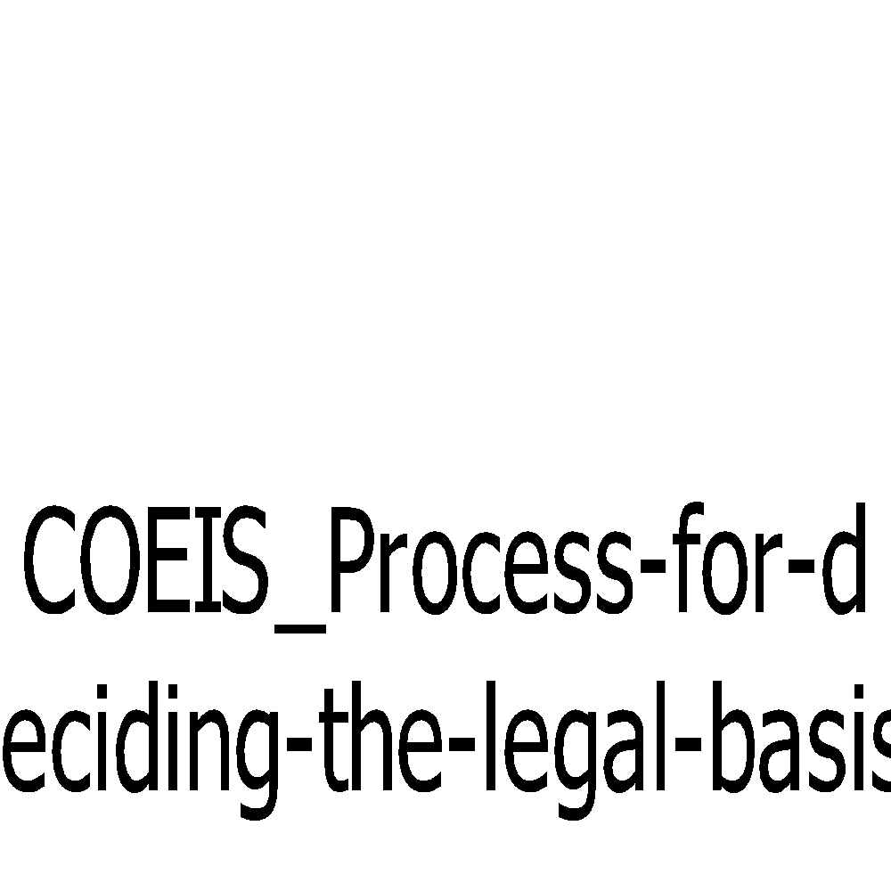
 | ☒Consent  ☐Public Interest or safeguarding individual/other  ☐Legal Duty  ☐COPI Regulations | ☐Yes  ☒No  ☐Don’t Know – seek advice from DSP  This approach supports surveillance of COVID19 and its potential management of further outbreaks. | ☒NHS Act 2006  ☒Health and Social Care Act 2012  ☐Local Authority  ☐Other Public Sector  ☐Private and 3rd sector (see PDF above)  ☒Data Protection Act 2018  ☐Other (details to be provided e.g. GDPR Recital 52– stating ‘Such a derogation may be made for health purposes, including public health and the management of health-care services’ as it will be used for the review/evaluation of services.)

DSP team to review the SCCs and complete with supplier if needed: | SCC

Section 1: Project Information
Lawfulness, fairness and transparency - Article 5(1)(a) of the GDPR says: “1. Personal data shall be: (a) processed lawfully, fairly and in a transparent manner in relation to the data subject (‘lawfulness, fairness, transparency’)”
- You must identify valid grounds under the GDPR (known as a ‘lawful basis’) for collecting and using personal data.
- You must ensure that you do not do anything with the data in breach of any other laws.
- You must use personal data in a way that is fair. This means you must not process the data in a way that is unduly detrimental, unexpected or misleading to the individuals concerned.
- You must be clear, open and honest with people from the start about how you will use their personal data.

Caldicott Principle 1: Justify the purpose for using confidential information

Caldicott Principle 6: Understand and comply with the law

Project Description – A summary of the project and the aims
1.1.1 | HEE’s Placement Expansion Programme has provided £10m of funding to support the growth of clinical placements in selected professions, including AHPs. The funding was set aside to support an increase in the number of placement opportunities offered to students, enabling HEE to deliver the future health and care workforce in sufficient numbers and with the skills the NHS needs.  The University of Liverpool and University of Sheffield were successful in their joint national bid to secure £90K of funding for Orthoptics. The funding will be used to put the infrastructure in place to support remote teaching, to develop a bank of online clinical resources within an online portal and for secondments to oversee the project.  [insert information specific to the workflows proposed to your trust for approval ie University Video consultations and/or Onsite trust video consultations and/or direct student video consultations and/or recording assessments]  The viewing/recording of remote Orthoptic investigations and remote discussions of real patients with clinicians is a way of students achieving virtual learning and developing clinical reasoning. This will enable students to maximize time spent having face to face clinical teaching and supervision.  The recording of Orthoptic investigations will be achieved with the use of the Hololens2 technology or iPad (delete as appropriate.)

How long do you expect this initiative to last?
1.1.2 | End of contract ☐  Specific time period ☒-specify This will be trust specific and depend on the date approval is attained and the progress of the project.  Lifetime of system ☒  The videos will remain on the portal for teaching purposes indefinitely but will be reviewed to ensure they remain appropriate and relevant to evidence based practice every 2 years.  Other ☐- specify

Does this project have any links or references to national guidance? Please evidence
1.1.3 | e.g. ICO/NHSx  No

What stage is the project currently at?
1.1.4 | e.g. Design/Implementation?  Initiation – determining and completing processes needed for trust approval of Hololens2/iPad recordings.  Recruiting virtual placement sites to undertake recordings.  Identifying and resolving risks related to the completion of the project.

Which divisional groups has this project been tabled for discussion and when?

1.1.5 | Trust specific

What information will be processed or accessed?

1.1.6 | Patients will be provided with a patient information leaflet (age appropriate) and consent form to complete if they are happy for their consultation to be recorded.  The information to be captured will be a video recording of a patients’ face to face Orthoptic consultation. Recording will include the patients face as it is not possible to include relevant eye movement observations and tests without this. The results of all the tests undertaken during the consultation will be visible on the video. During the consultation, although care will be taken to not include the patient’s name, DOB, address etc, details about their condition (either eye condition or previous medical history and medication) may be discussed during the consultation as they could be relevant in terms of making a diagnosis or management plan. This is a key part of the consultation and should not be omitted as it represents important clinical decision making learning opportunity. This is outlined in the patient information.  Orthoptists assess all ages of patients and therefore it is intended that videos would reflect this – including both adults and children.  Patients name, DOB and contact details will be saved on the restricted admin area of the BIOS website to facilitate the process of identifying the relevant videos to be removed should the patient withdraw consent at a later date.

Is the data already captured by the Trust for this purpose?

1.1.7 | Yes ☐ No ☒ Although this information (test results and details about their condition (either eye condition or previous medical history and medication) is recorded in the patients record as part of their normal orthoptic consultation no part of the clinical consultation is currently videoed.
Note 1.1.7 UHNM has not previously captured this data however from 21/05/20 this potential exists as the pilot system has been installed.

Please provide details of the data collection and storage process. Please state if the data is stored in electronic or paper format. If electronic provide the system name or state if MS office based dataset. Is the system currently used by the Trust or proposed new system? Will data be stored on site, or by an external third party? Will it be stored on a device or trust shared drive?
1.1.8 | Data is stored in electronic format.  [insert information specific to the workflows proposed to your trust for approval ie University Video consultations and/or Onsite trust video consultations and/or direct student video consultations and/or recording assessments]  The video recording will be stored locally to the ipad/Hololens hard drive, login authentication will be required to access these files and encryption of these devices will need to be determined by the Trusts local IT team.  Clinical Leads will be able to complete an online form on the BIOS portal to capture the patients consent. The patients name DOB, contact details, appointment date, will be stored on a password protected database, which will be only accessible by the BIOS administrator via the restricted area of the BIOS portal. The access to the restricted area will be determined by the allocated user role, which will be managed and regularly audited by the BIOS administrator.  Once the form has been submitted, the database will return a VideoID, which will determine the unique identifier to be used as part of the video file naming convention.  The Lead Clinical Tutor will be responsible for cutting and pasting the file from the Hololens/iPad/Microsoft Teams cloud, to a secure Trust network drive using the agreed file naming convention. The file is then to be uploaded to the secure Vimeo Pro BIOS account where the media files will be made non-shareable/downloadable. Once the file is available on Vimeo, the BIOS Clinical Expansion lead (who is also a registered Orthoptist at an NHS Trust) will edit the video using the built-in video editing tools in Vimeo. The video will be edited to enhance the subjects learning by adding annotations where appropriate and trim the video to ensure only the most relevant information is available. Once complete the file will then be promoted to the secure, members only area of the BIOS portal, where BIOS members will be required to login with a username, password and electronically sign a disclaimer to gain access to the content.  Please see Approval guide

How often will you be collecting and using the personal data?

1.1.9 | This will vary between sites and be determined by suitability of clinics/patients, numbers of patients willing to participate, and numbers of available tutors to undertake the recordings/consultations. To utilise the hardware optimally for the duration of the project ideally (where possible) the Hololens/iPad will be in daily use. [Please add an estimate of your proposed activity]

How often will the new system, process or data flow be audited? Each partner organisation should have a programme of audit in place for their respective systems that tests for patterns of access, inappropriate access etc. that is routinely undertaken.
1.1.10 | At the start of the project BIOS will aim to audit access to the portal on a fortnightly basis, with the view to decreasing the frequency if no further issues are identified.  This will involve auditing who has accessed which videos on the site.

Approximately how many data subjects will this process involve?
1.1.11 | This will vary between sites depending on patient participation and tutor availability. An estimation would be approximately 3-10 patients per week for the duration of the project. [Please add an estimate of your proposed activity]

How are data subjects informed of the processing? What information are they provided with?

1.1.12 | Patients will be posted an age appropriate patient information sheet with their appointment letter – outlining the project details in patient accessible language. A consent form will also be included. [see appendices for copies of this documentation]  Before the patients’ appointment they will be contacted by phone to give them an opportunity to ask any questions regarding the project. If they decide they would like to participate then they will be asked to complete the written consent form and bring it with them to their appointment.  [see relevant workflow for further detail if required]

How much control will the data subjects have over the data being processed?

1.1.13 | The subjects can withdraw from the project at any time if they feel they no longer want their data included on the portal. Their data will then be immediately and permanently removed.  On consenting to participate in this project, the patient will be given a copy of their consent for and the associated unique VideoID.  An online form will be added to the public area of the BIOS website to allow patients to formally submit their consent withdrawal. This will trigger an email to the BIOS administrator for them to action the consent withdrawal. All associated media will be immediately and permanently removed by the BIOS administrator, from the associated video hosting site (Vimeo) and the BIOS portal. The BIOS administrator will send notification to the patient once the request has been successfully actioned.  A telephone number will also be provided for those patients who are do not use computers – in this circumstance they can contact BIOS administrator and ask for their content to be removed.  [see workflow for further detail]  If the patient is not able to provide their unique video ID it will still be possible to locate the patients media files, as their name, DOB and contact details will be saved within the password protected Consent Database in the restricted area of the BIOS website.

Would they expect you to use their data in this way?

1.1.14 | Yes ☒ No ☐ Don’t Know ☐ As a teaching hospital, patients expect some aspects of their consultation to be used for the purpose of education. This already occurs frequently within the department and trust with face to face clinical placements. [or trust specific]

Purpose Limitation- Article 5(1)(b) of the GDPR says: “ Personal data shall be: collected for specified, explicit and legitimate purposes and not further processed in a manner that is incompatible with those purposes; further processing for archiving purposes in the public interest, scientific or historical research purposes or statistical purposes shall, in accordance with Article 89(1), not be considered to be incompatible with the initial purposes.”
- You must be clear about what your purposes for processing are from the start.
- You need to record your purposes as part of your documentation obligations and specify them in your privacy information for individuals.
- You can only use the personal data for a new purpose if either this is compatible with your original purpose, you get consent, or you have a clear obligation or function set out in law.
Caldicott Principle 2 - Don’t use personal confidential data unless absolutely necessary
Are there links to any wider initiatives?

1.2.1 | Yes ☒ No ☐  Please provide details: Health Education England’s (HEE) Placement Expansion Programme

Data minimisation- Article 5(1)(c) of the GDPR says: Personal data shall be adequate, relevant and limited to what is necessary in relation to the purposes for which they are processed (data minimisation)”
You must ensure the personal data you are processing is:
- adequate – sufficient to properly fulfil your stated purpose;
- relevant – has a rational link to that purpose; and
- Limited to what is necessary – you do not hold more than you need for that purpose.
Caldicott Principle 2: don’t use personal confidential data unless absolutely necessary
Caldicott Principle 3: use the minimum necessary personal confidential data
What consideration has been taken to ensure that only the minimum data necessary is captured?

1.3.1 | Recording will include the patients face as it is not possible to include relevant eye movement observations and tests without this. The results of all the tests undertaken during the consultation will be visible on the video. During the consultation, although care will be taken to not include patients name, DOB, address etc, details about their condition (either eye condition or previous medical history and medication) may be discussed during the consultation as they could be relevant in terms of making a diagnosis or management plan. This is a key part of the consultation and should not be omitted as it represents important clinical decision making learning opportunity.
If the information is to be anonymised or pseudonymised in any way, specify how this will happen?

1.3.2 | Videos will be saved as per a naming convention including a Unique video ID on the BIOS portal. This naming convention is as follows and includes no patient identifiable information.  e.g RSUH (site code) 03 (video ID) -25022021 (date of appointment) –DRAFT (version)  RSUH03-25022021 - DRAFT  The patients name, DOB and contact details will be saved with their corresponding video ID in the restricted admin area of the BIOS website – this is only accessible by BIOS administrator.

What processes will be in place to delete the data when it is no longer required to be retained?

1.3.3 | All patient data and associated media files can be permanently deleted, by the BIOS administrator as and when a patient withdraws their consent.  Please see Approval Guide for further information.

Accuracy- Article 5(1)(d) of the GDPR says: Personal data shall be: accurate and, where necessary, kept up to date; every reasonable step must be taken to ensure that personal data that are inaccurate, having regard to the purposes for which they are processed, are erased or rectified without delay (‘accuracy’)”
- You should take all reasonable steps to ensure the personal data you hold is not incorrect or misleading as to any matter of fact.
- You may need to keep the personal data updated, although this will depend on what you are using it for.
- If you discover that personal data is incorrect or misleading, you must take reasonable steps to correct or erase it as soon as possible.
- You must carefully consider any challenges to the accuracy of personal data.
Caldicott Principle 6: Understand and comply with the law
How will the accuracy (data quality) of the data be maintained?

1.4.1 | Even though multiple Orthoptists will be trained from within the department to record their patients assessments it will be done so under the supervision of the Lead Clinical Tutor. Only the Lead Clinical Tutor will be responsible for ensuring the file is accurately uploaded to vimeo and accessible through the BIOS portal. The Lead Clinical Tutors will be trained by the BIOS Technical Support role to ensure all files are securely uploaded with the agreed naming convention and that the patients consent is accurately recorded. Before the data is made accessible via the BIOS Portal, the BIOS Clinical Expansion leads will review the video, to make sure the content is clinical viable and ensure the file has been uploaded with the correct file naming convention and the necessary security protocols have been followed. Any video files that do not meet the agreed security provisions, will be permanently deleted. The Lead Clinical Tutor will be notified of any issues found and will be reminded of the security protocols that must be adhered before attempting to re-upload the video file.

Storage limitation- Article 5(1)(e) of the GDPR says: Personal data shall be: kept in a form which permits identification of data subjects for no longer than is necessary for the purposes for which the personal data are processed; personal data may be stored for longer periods insofar as the personal data will be processed solely for archiving purposes in the public interest, scientific or historical research purposes or statistical purposes in accordance with Article 89(1) subject to implementation of the appropriate technical and organisational measures required by this Regulation in order to safeguard the rights and freedoms of the data subject (‘storage limitation’)”
- You must not keep personal data for longer than you need it.
- You need to think about – and be able to justify – how long you keep personal data. This will depend on your purposes for holding the data.
- You need a policy setting standard retention periods wherever possible, to comply with documentation requirements.
- You should also periodically review the data you hold, and erase or anonymise it when you no longer need it.
- You must carefully consider any challenges to your retention of data. Individuals have a right to erasure if you no longer need the data.
- You can keep personal data for longer if you are only keeping it for public interest archiving, scientific or historical research, or statistical purposes.
Caldicott Principle 5: Everyone with access to personal confidential data should be aware of their responsibilities
Caldicott Principle 6: Understand and comply with the law

How long will the information be kept?

1.5.1 | Indefinitely with 2 year review to ensure that material remains relevant.

How will the information be destroyed at the end of the retention period?

1.5.2 | It will be permanently deleted from the server hosting the content (Vimeo), once removed it will not be possible to add the content back.

Integrity and confidentiality (security)- Article 5(1((f) states You must ensure that you have appropriate security measures in place to protect the personal data you hold.
Caldicott Principle 4: access to personal confidential data should be on a need to know basis
Caldicott Principle 5: everyone with access to personal confidential data should be aware of their responsibilities.
Caldicott Principle 7: the duty to share information can be as important as the duty to protect patient confidential data

Who will have access to the data? Appropriate technical and organisational security measures:

1.6.1 | All UHNM Staff ☐ Individual UHNM Staff member ☐  Specific UHNM team/dept. ☐ Third Party ☒  Please provide approximate numbers if accessed by team or third party and how access  levels will be restricted: -  Full BIOS members and student BIOS members. (approximately 1,300 in total)

How will the data be accessed?

1.6.2 | Onsite ☐ Remote ☒ Off Site ☐  Videos will be accessed through the BIOS portal. The portal will only be accessible once the BIOS member/student member has logged in to the members area of the website.  Although videos will be hosted on Vimeo they will not be accessible or searchable here or in any other location, apart from the BIOS portal. To access the content, users will be required to electronically sign a disclaimer regarding appropriate use of the BIOS portal. This disclaimer will be triggered the first time they access the BIOS Portal and every subsequent month. [declaimer included in Approval guide (appendix A) if required]  Universities will also be required to complete data protection training with all students, as part of their undergraduate programme.  Any data stored in the restricted area of the BIOS Portal will be managed by the BIOS administrator. The BIOS Administrator will be employed directly by the professional body, BIOS. This role will have access to the secure consent database on the BIOS portal, where they will be able to see patient names/DOB and their contact details. This information will enable the BIOS Administrator to action any patient consent withdrawals as it will ensure all associated media can be easily identified and permanently deleted. This role will also have access to the activity audit trails on the BIOS Portal and the BIOS user accounts/permissions. Further to this, they will be responsible for regularly auditing this data to identify and action any suspicious activity.

Supplier Details
1.6.3
Supplier: |  | Douglas Digital Ltd
Product: |  | BIOS portal
Service Being Provided: |  | BIOS portal

Does the supplier have a contract with the Cloud Supplier?
(attach a copy of the cloud security element?)
1.6.4 | Due to the size of the storage required for hosting the patient assessment videos, an external Video Hosting website needs to be utilised. As BIOS already use Vimeo-Pro for hosting Continue Professional Development (CPD) videos, approval will be sought for the use of Vimeo for hosting this projects content. If Vimeo does not meet the necessary Trusts security requirements, can an alternative Video Hosting Site be suggested by the Trust?
Does the Supplier have Business Continuity Plans (attach evidence)?
1.6.5 | A downtime policy will be developed to determine the process that must be followed, to ensure the recorded video file is stored on a secure network drive, associated to a copy of the patients scanned consent form and that a suitable temporary file naming convention is followed, (e.g. where the Lead Clinical Tutor was unable to register the patients consent for the return of the unique VideoID).  As the proposed storage of the recorded patient assessment has no impact on patient care within the trust, any downtime experienced with the BIOS Portal would simply mean the process of uploading the content would be placed on hold until access to the BIOS PortaI was re-gained.

If information is to be shared, stored or accessed by a third party, please provide a description of the process including transfer and access authorisation methods.
1.6.6 | [insert information specific to the workflows proposed to your trust for approval ie University Video consultations and/or Onsite trust video consultations and/or direct student video consultations and/or recording assessments]  The information will be accessed by students and clinical tutors (who are BIOS members) for educational purposes.  [Depending on which workflow has been selected at the trust the information will be shared live, through video consultation on Microsoft teams, or by viewing the content on the BIOS portal.]  The video recording will be stored locally to the ipad/Hololens hard drive, login authentication will be required to access these files and encryption of these devices will need to be determined by the Trusts local IT team.  The Lead Clinical Tutor will be responsible for cutting and pasting the file from the Hololens/iPad/Microsoft Teams cloud, to a secure Trust network drive using the agreed file naming convention.  The file is then to be uploaded to the secure Vimeo Pro BIOS account where the media files will be made non-shareable/downloadable.  Once the file is available on Vimeo, the BIOS Clinical Expansion lead (who is also a registered Orthoptist at an NHS Trust) will edit the video using the built-in video editing tools in Vimeo. The video will be edited to enhance the subjects learning by adding annotations where appropriate and trim the video to ensure only the most relevant information is available.  Once complete the file will then be promoted to the secure, members only area of the BIOS portal, where BIOS members will be required to login with a username, password and electronically sign a disclaimer to gain access to the content.

State information transfer method:

1.6.7 | Email – nhs.net ☐ Email – non nhs.net ☐ Fax ☐ E-fax ☐  Telephone ☐ Post ☐ By hand ☐ System feeds ☐  Other – see section 1.6.6 Options available

National Data Opt Out:
For purposes other than the provision of direct healthcare, the Trust is required to consider a request to Opt-Out of any data sharing.

National data opt-out (should a patient request it) applies to the use of all confidential patient information for research and planning purposes.
The national data opt-out does not apply where:
- data is shared for direct patient care
- there is a risk to public health or data is required for monitoring and control of infectious diseases
- there is an overriding public interest; for example: reporting of gun wounds in line with GMC guidance
- there is a legal requirement to share information; for example: investigations by regulators of professionals (e.g. General Medical Council investigating a registered doctor’s fitness to practice)
- NHS fraud investigations
- notification of food poisoning
- consent obtained to take part in a specific project
- anonymised data is used
- data is used for local clinical audit
- data forms part of a national patient experience survey
When a national data opt-out needs to be applied, the entire record; or records, associated with that individual must be fully removed from the dataset used for this purpose.
National Data Opt Out - Provide advice on how the project will meet this requirement:
1.6.8 | N/A as patients will provide consent to take part.

Will the project require information to be transferred outside of the UK, or to receive information or be accessed from overseas?

1.6.9 | Yes ☐ No ☒  If yes please provide details:

If a Third party is involved, what arrangements are or need to be in place with the Trust, if known?

1.7.1 | Contract ☒ SLA ☒ Framework Agreement ☐  Commissioned Service ☐ Sharing Agreement ☐  Please provide details:  [these can be provided if required]
If known/applicable what information security procedures does the third party have in place?

1.7.2 | ICO registration Number ☒ Reference: ZA381753  Data Security Protection Toolkit Compliance ☐ Status:  ODS Code:  ISO Security 27001 ☐  Please provide details (embed Certification if available):

Screenshot of the Data Security and Protection Toolkit status

1.7.3 | No Submission made

Data subject rights

How can data subjects exercise their rights of access and to data portability?

1.7.4 | The Data Subjects right’s for project are outlined in the Douglas Digital GDPR Assurance Document below.  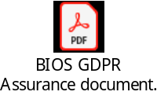  Data subject rights as part of their direct care is outlined in the Trust’s privacy policy.  http://www.uhnm.nhs.uk/privacy-notice/

How can data subjects exercise their rights to rectification and erasure?

1.7.5 | The Data Subjects right’s for project are outlined in the Douglas Digital GDPR Assurance Document below.  Data subject rights as part of their direct care is outlined in the Trust’s privacy policy.  http://www.uhnm.nhs.uk/privacy-notice/

How can data subjects exercise their rights to restriction and to object?

1.7.6 | The Data Subjects right’s for project are outlined in the Douglas Digital GDPR Assurance Document below.  Data subject rights as part of their direct care is outlined in the Trust’s privacy policy.  http://www.uhnm.nhs.uk/privacy-notice/

DSP USE ONLY

Is there enough information to be assured that Principle 1 is met YES ☐
NO ☐

Section 2: Data Items
Personal Identifiable Data:
2.2.1 | Personal details - Check all that apply:  Other – List any other data items or attach as an appendix  Pseudonymised Information – Check all that apply:  Special Categories of Personal Data – Check all that apply:  Other – List any other data items or attach as an appendix
  ☒Forename | ☐Physical Description | ☐Location data e.g. IP address
  ☒Surname | ☒Home Tel. Number | ☒Mobile Phone Number
  ☐A  ddress | ☒Other Contact number | ☐Legal Representative Name (Next of Kin)
  ☐Post code (full) | ☒Email Address | ☐NHS number
  ☐Post code (partial) | ☐GP Details | ☒Photographs/Images (PID)**
  ☐Date of Birth | ☒Age | ☐Other
  ☒Gender | ☐National  Insurance No.
  ☐Unit Number | ☒Other ID number
  ☐Racial or Ethnic Origin | ☐Political Opinion | ☐Religious Beliefs
  ☐Trade Union Membership | ☒Physical or  mental Health | ☐Sexual Life
  ☐Sexual Orientation | ☐Genetic Data | ☐B  iometric Data

Declaration

2.2.2 | You must confirm that the data items you have ticked above are relevant and necessary to your project and there is a justified reason for it –if they are not you must amend the above selections to remove those items not relevant/necessary  If the Data is to be used for any other purpose then this DPIA will need to be reviewed or a 2nd DPIA will need to be completed,  the DSP team will be able to advise  Project Lead Confirms Understanding ☐

Section 5 - GDPR
Description | Details
Identity of the Controller and Processor | BIOS / Douglass Digital
Subject matter of the processing | Video recordings of patient consultations (Orthoptic assessments) including images of the patients’ face and eyes, clinical discussions regarding their vision and information relevant to their eye condition and clinical examinations and tests of the eyes.
Duration of the processing | Trust specific
Nature and purposes of the processing | The purpose of recording these consultations is to provide them as a teaching resource for undergraduate Orthoptic students.  The videos will be stored on an external hosting site (Vimeo) and accessed via a secure online portal developed by the British and Irish Orthoptic Society. Access to the portal will require member log in and acceptance of a disclaimer in terms of appropriate use of data.  The videos may be edited with voice over the provide explanation where appropriate to improve learning opportunities. They may also be cropped if aspects of the consultation are not relevant to learning outcomes.  The videos will be removed if the patient withdraws their consent or at the end of the project.
Type of Personal Data | Video Patient Content
Categories of Data Subject | Patients
Plan for return and destruction of the data once the processing is complete unless requirement under union or member state law to preserve that type of data.  (Return/Destruction will apply to all applicable data and can and will take place throughout a contract period i.e. in line with legal retention periods for the relevant data type or when a particular dataflow is now longer required.) | Indefinitely with 2 year review to determine if video is still relevant to teaching purposes.

Appendix F – BIOS Portal Disclaimer

DRAFT Confidentiality disclaimer to be triggered for new and existing BIOS member registrations to ensure all members are aware of what is deemed inappropriate use, of the BIOS learning portal:
By clicking ‘Accept’, I understand, accept and agree to be bound by the requirements of the Data Protection Act (2018) and the principle of confidentiality of patient records and patient data. I will not make copies (including photographs, recording or screen-grabs) of the images or recordings of patients kept within the BIOS learning portal. I will not share or distribute the images within with anyone else. I confirm that I am using my own log-in details, that I have completed the e-Learning for Healthcare Data Security Awareness online module, and I understand that my activity within this portal will be monitored and analysed using cookies. We will not share any of your data with advertisers or third parties.

Appendix G – Clinical Expansion Project Risk Log

 | Report Depth: 1 |  |  |  |  |  |  |  |  |  |  | Plan: |  |  | Clinical Expansion Project |  |  |  |  |  |  |  | Produced: |  |  | 21/02/2021
Code |  | Risk Owner | Type | Risk Description |  |  |  |  | Inherent Severity |  | Inherent Likelihood |  | Inherent Risk Rating | Residual Severity |  | Residual Likelihood | Residual Risk Rating | Status | Escalation |  |  | Avoidance / Mitigation Action |  | Status Update | Last Updated  By |  | Last Updated
03004 |  | Michelle Murray | Operational Risk | Trusts may not allow clinicians to perform live patient video consultations with universities/students. |  |  |  |  | Major |  | Possible |  | 12 | Major |  | Possible | 12 | Open |  |  |  | Process maps, patient consent letters and student disclaimers etc, will be shared with the clinical tutors at each site to help them achieve sign off from information governance/PEF for patient/student/university consent.  Depending of the trusts approval of video consultations, the contingency plan is to deliver video consultations in two phases:  1. Universities access the video consultations - they maintain control of the video footage and invite students to attend lecture theatres to join the consultations in small groups.  2. Students have direct access to the video consultations. |  | 02/02 - Approval Guide shared with Site Clinical Tutors.  09/02 - Meeting organised with Site Clinical Tutors to review their progress at achieving consent. | Michelle Murray |  | 21/02/2021
03009 |  | Michelle Murray | Operational Risk | Trusts may not approve the recording of patient consultations for storage on the external BIOS Portal. |  |  |  |  | Major |  | Possible |  | 12 | Major |  | Possible | 12 | Open |  |  |  | Approval Guide has been shared with Site Clinical Tutors and progress will be tracked at the project team meetings. |  | 02/02 - Approval Guide shared with Site Clinical Tutors.  09/02 - Meeting organised with Site Clinical Tutors to review their progress at achieving consent. | Michelle Murray |  | 21/02/2021
03006 |  | Michelle Murray | Operational Risk | Students may not conform to the agreed disclaimer. |  |  |  |  | Moderate |  | Possible |  | 9 | Moderate |  | Possible | 9 | Open |  |  |  | The disclaimer will need to be reviewed in line with this new technology.  Unfortunately no matter how good the disclaimer is, this will always pose a risk. Universities will need to provide assurance that they have protocols in place to ensure students have adequate training and that if there is a breach then appropriate action will be taken. |  | 18/02 - Student disclaimers are currently being gathered from universities. Once finalised, the information will be available from the Approval Guide. | Michelle Murray |  | 21/02/2021
03008 |  | Michelle Murray | Quality | Hololens have had reports of issues with the resolution, battery and memory limitations. This needs to be tested in line with Hololens2. |  |  |  |  | Moderate |  | Possible |  | 9 | Minor |  | Unlikely | 4 | Open |  |  |  | Thorough testing will be completed as soon as we can get access to the technology. Any identified risks and issues, will receive a mitigation plan to ensure each organisation is aware of the best practise surrounding the technology to enable high quality video consultations. |  | 02/02 - After a demonstration from Insight, assurance was given that the technology had improved since the original Hololens release. Risk rating reduced. | Michelle Murray |  | 21/02/2021
03001 |  | Michelle Murray | Operational Risk | Wireless infrastructure at hospital sites may not meet the minimum requirements to enable successful video consultations |  |  |  |  | Major |  | Unlikely |  | 8 | Major |  | Unlikely | 8 | Open |  |  |  | Lead Clinical Tutors to request a heat map survey from their hospitals Network Team. These heat maps will indicate potential black spots which may cause issues. A decision will then need to be made to agree whether the Hololens technology can be used solely in an area with good/excellent wifi capabilities and if not can the Hololens be hardwired to the trusts network? |  | 02/02 - Approval Guide shared with Site Clinical Tutors.  09/02 - Meeting organised with Site Clinical Tutors to review their progress at achieving consent. | Michelle Murray |  | 21/02/2021
03003 |  | Michelle Murray | Operational Risk | Trusts may not agree to Hololens technology using their wireless network |  |  |  |  | Major |  | Unlikely |  | 8 | Major |  | Unlikely | 8 | Open |  |  |  | From past experience with Wirral University Teach Hospital, the network team can be obstructive with adding unfamiliar technology to the network. Aim is to work with Insight to collate technical specifications to share with IT departments, to minimise the risk of them rejecting the hardware on their network. |  | 02/02 - Approval Guide shared with Site Clinical Tutors.  09/02 - Meeting organised with Site Clinical Tutors to review their progress at achieving consent. | Michelle Murray |  | 21/02/2021
03002 |  | Michelle Murray | Dependency | Clinical tutors may not engage with the project. |  |  |  |  | Moderate |  | Unlikely |  | 6 | Moderate |  | Unlikely | 6 | Open |  |  |  | Every effort will be made to engage with all identified clinical tutors. The aim is to set up fortnightly project meetings to monitor each sites progress. Consistent non-attendance at these project teams meetings will be escalated to the Hololens board. |  | 02/02 - Technical support role has met with all clinical leads and organised a monthly meeting from 22nd Feb. Once clinical pressures reduce regarding the Covid-19 pandemic, the frequency of these meetings will be increased to fortnightly. | Michelle Murray |  | 21/02/2021
03005 |  | Michelle Murray | Dependency | Patients' may not be willing to participate in live video consultations with universities. |  |  |  |  | Moderate |  | Unlikely |  | 6 | Moderate |  | Unlikely | 6 | Open |  |  |  | Patients will be approached prior to their appointment to identify the patients who are likely to participate. Until the Trusts have completed this process, it is unknown whether patients will be willing to participate. |  |  | Michelle Murray |  | 21/02/2021
03007 |  | Michelle Murray | Staff | Clinicians may not like wearing the Hololens2 technology |  |  |  |  | Moderate |  | Unlikely |  | 6 | Moderate |  | Unlikely | 6 | Open |  |  |  | Trusts will be given time to trial the headsets, to ensure end users can find the best fit for them. |  |  | Michelle Murray |  | 21/02/2021
03010 |  | Michelle Murray | Staff | With the national lockdown, we may find that site clinical leads cannot commit to the project at present, due to other Covid-19 priorities. |  |  |  |  | Moderate |  | Possible |  | 9 | Moderate |  | Possible | 9 | Open |  |  |  | Monthly project team meetings have been organised with Site Clinical Tutors. Once clinical pressures have reduced, fortnightly meetings will be organised. |  | 16/02 - To date, we have had a 9 out of 12 accept our invitation for the Clinical Expansion meeting. | Michelle Murray |  | 21/02/2021
03011 |  | Michelle Murray |  | Undecided who will take forward the role of editing recorded assessments after the 9 month secondment comes to an end. |  |  |  |  | Moderate |  | Unlikely |  | 6 | Moderate |  | Unlikely | 6 | Open | To be escalated to project board. |  |  | To be reviewed as part of the retention policy, with BIOS |  | 29/01 - Veronica stated "A retention policy was discussed today for BIOS and consenting procedures mainly to do with the journal but would be relevant to this project - we could raise this with Rich who is going to write the retention policy" | Michelle Murray |  | 21/02/2021
03012 |  | Michelle Murray | Staff | Who will audit the BIOS portal and keep consent up to date after the clinical tutor secondment is complete? |  |  |  |  | Major |  | Possible |  | 12 | Major |  | Possible | 12 | Open | To be escalated to project board. |  |  | To be reviewed as part of the retention policy, with BIOS |  | 29/01 - This will need to be considered as part of the retention policy. | Michelle Murray |  | 21/02/2021
03013 |  | Michelle Murray | Operational Risk | Insight have confirmed that at present Hololens will not work with Google Meet. |  |  |  |  | Moderate |  | Possible |  | 9 | Moderate |  | Possible | 9 | Open | To be escalated to project board. |  |  | To be discussed at Project Board. |  | 29/01 - Veronica stated "I think this is ok as students can access teams even if it is not the HEI preferred platform - Helen would be able to answer this best ". Helen stated "As I understand it the students would be able to access although UoS is a google university and doesn’t support Teams. I said I would get back to our learning technologist when I knew more."  21/02 - This needs to be discussed further in our project board meeting on 24/02/21. | Michelle Murray |  | 21/02/2021
03014 |  | Michelle Murray | Financial | Insights recommended video platform is Microsoft Teams, however this incurs a maximum cost of £49 per month per device, for the associated Remote Assist License. |  |  |  |  | Moderate |  | Possible |  | 9 | Moderate |  | Possible | 9 | Open | To be escalated to project board. |  |  | This information will be validated with Insight at the agreed demonstration on 29/01/21. |  | 29/01 - Veronica stated, "Yes - initially in the set up costs and would then take to BIOS board to approve ongoing cost - this is where we need to know the devices will be used to the max and not sat in a cupboard....".  Helen stated, "I agree we need to make sure they will be used." | Michelle Murray |  | 21/02/2021
03015 |  | Michelle Murray |  | NHS Digital have confirmed that the National DPIA signed for teams is only for video calls between NHS colleagues. A local trust DPIA agreement would need to be drawn up to enable patient video calls via Teams. |  |  |  |  | Moderate |  | Possible |  | 9 | Moderate |  | Likely | 12 | Open | To be escalated to project board. |  |  | To be discussed at Project Board. |  | 18/02 - To be reviewed at the Clinical Expansion meeting on 22nd February. | Michelle Murray |  | 21/02/2021
03016 |  | Michelle Murray | Financial | Douglas Digital have confirmed they will not be able to store media content on their web server, therefore an external video host like You Tube will need to be considered. External video hosting platforms are unlikely to get approval from NHS Trusts |  |  |  |  | Moderate |  | Possible |  | 9 | Moderate |  | Likely | 12 | Open | To be escalated to project board. |  |  | To be discussed at Project Board. |  | 18/02 - Douglass Digital have confirmed the only options available to us are to host the videos via a site called 'Vimeo' as apparently they are known for their improved security features. Alternatively the video could be hosted via a private video hosting site. Further research is required on both these options, so the information can be shared with the Site Clinical Tutors to enable them to seek approval from their trusts. | Michelle Murray |  | 21/02/2021
03017 |  | Michelle Murray | Operational Risk | Attend Anywhere has a National DPIA approved for its use with patients, however this application does not permit recording of video consultations and is not accessible via the Hololens. |  |  |  |  | Moderate |  | Possible |  | 9 | Moderate |  | Possible | 9 | Open |  |  |  | To be discussed at Project Board. |  | 29/01 – Veronica stated “In my simple brain these are 2 diffetnt things - we are not using the Hololens as a form of remote consultation with the patients as in AA where this replaces a face tp face interaction but instead as a recording of the face to face interaction with the patients and the tests / assessment so students get as close  Helen stated “We had discussed whether there was any way we could facilitate students being part of Attend Anywhere appointments. A different experience but still useful in many aspects” | Michelle Murray |  | 21/02/2021
03018 |  | Michelle Murray | Operational Risk | Hololens device may not be medical grade plastic to enable appropriate cleaning after each patient assessment to ensure infection control. |  |  |  |  | Major |  | Likely |  | 16 | Major |  | Likely | 16 | Open |  |  |  | Request for insight to provide assurance of the plastic grade used on the Hololens technology and the appropriate cleaning methods to be used to ensure the device is cleaned to infection control requirements. |  | 18/02 - Email send to Phil Moore from Insight for confirmation. | Michelle Murray |  | 21/02/2021
03019 |  | Michelle Murray | Operational Risk | May struggle to wear the device under a visor, which is mandatory during the Covid-19 pandemic. |  |  |  |  | Major |  | Possible |  | 12 | Major |  | Possible | 12 | Open |  |  |  | Ask Insight to send assurance that the Hololens can be worn under a visor. |  | 18/02 - Email send to Phil Moore from Insight for confirmation. | Michelle Murray |  | 21/02/2021

Appendix H – Students University Disclaimers/Declarations
I understand, accept and agree to be bound by the requirements of the Data Protection Act (2018) and the principle of confidentiality of patient records and patient data. I will not make copies (including photographs, recording or screen-grabs) of the images or recordings of patients during the live stream consultation or within the BIOS PERL.
I will not share or distribute the Microsoft teams meeting information to anyone else.
I will not share or distribute the images on the BIOS PERL with anyone else. I confirm that I am using my own log-in details, that I have completed the e-Learning for Healthcare Data Security Awareness online module, and I understand that my activity within the PERL will be monitored and analysed using cookies.

Appendix I – Video Hosting Website - Vimeo

- Vimeo
Advantages to using Vimeo YouTube:
- Quality: YouTube's mantra is quantity over quality. Users upload more than 500 hours of footage to YouTube every single minute. And YouTube needs to process all of these videos before they can go live. In order to handle that kind of load, YouTube must balance compression speed with compression quality. On the other hand, Vimeo's mantra is quality over quantity. Because Vimeo has stricter guidelines for acceptable videos, its processing load is far lighter than YouTube's. And that means it can focus more on maximizing the quality of each video using better encoding techniques. If you upload the same video to both YouTube and Vimeo at the same resolution, the Vimeo version will look a lot better because it will have a much higher bitrate.
- Replace video but keep URL: This is one of Vimeo's best features. You can replace any of your existing videos with a new upload without losing its URL, thus keeping all of the likes, comments, stats, and not breaking any embeds that may exist on third-party sites.
- Password protection: You can set a password on any video so that only those with the password can view it. YouTube doesn't have this feature, only allowing videos to be Public, Private, or Unlisted.
- Domain-restricted embeds: Vimeo lets you set which domains are allowed to embed your videos, and you can do this on a per-video basis. This way you can hide your videos on the Vimeo site itself and only make them viewable on your site.
- Web player branding: Vimeo lets you alter the appearance of its HTML5 web player by inserting your own logo and branding, which is great when embedding videos on your site, whereas embedded YouTube videos always look the same and end with that unsightly suggestions page.
- Advanced analytics: Depending on your subscription level you can get various levels of analytics, starting with a traffic dashboard and custom reports, going all the way to engagement graphs and Google Analytics integration.
- Make money with pay-per-view: Vimeo On Demand lets you create dedicated VOD pages where viewers can pay to watch videos. You can sell worldwide or only in certain countries, and you keep 90 percent of the revenue. This is a convenient way to make money from your work without employing ads.
- Plus, Pro, Business, Premium plans: Unlike YouTube, Vimeo is funded by its community rather than advertisers. You CAN use Vimeo for free, but free accounts are limited to 500 MB of uploads per week. Vimeo Plus costs $7/month, Pro costs $20/month, Business is $50/month, and the top-tier Vimeo Premium is $75/month.
Further information about Vimeo’s privacy settings can be found at Privacy settings overview – Vimeo Help Center
Vimeo has various pricing plans available to each offering different benefits. Both BIOS and the clinical expansion team have reviewed the pricing strategy and are considering Vimeo Pro. Pricing plans | Vimeo Pro, Plus, Business, Premium, Enterprise & OTT
Vimeo pro
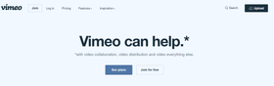
Domain level privacy | With domain level privacy, your content can only be embedded to your website. This is the same as the domain whitelisting and domain hotlinking feature.
Restrict downloads | Another useful feature offered by Vimeo’s private video hosting service is the ability to disable downloads.
Password protection | Easily create a password that is required to view your content. Unlike wistia, vimeo pro allows you to lock a single video with a password.
Unlisted videos | Vimeo pro’s video hosting service allows you to keep some videos hidden from public view and make them accessible only to your collaborators.
Private sharing link | Like all of the rest of the video hosting sites on this list, vimeo allows you to generate a private sharing link and send it.
Copyrights | Whenever you upload to vimeo, you give them “the right and license to copy, use, distribute, publicly perform, and display the licensed work” in order for them to properly deliver their services. You also waive any 'moral rights'. This doesn't necessarily mean that they will make your video available for public download without your knowledge, but, technically, they do have the right to do so. You can read more about vimeo’s terms here.

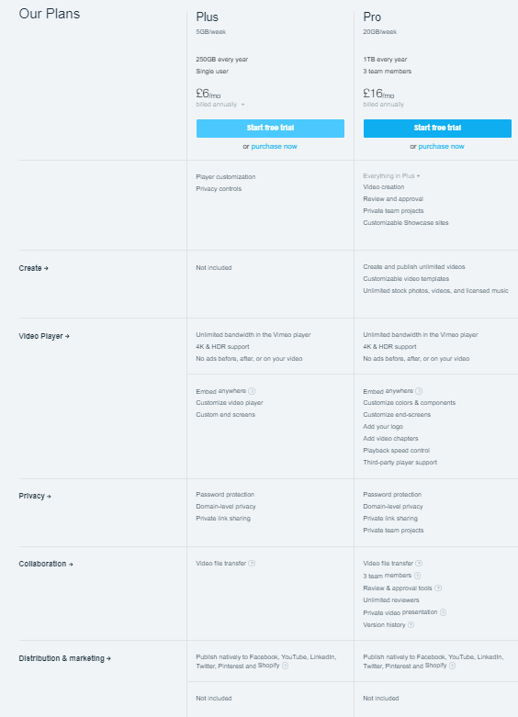

Appendix J – Patient Information Leaflets (Adults)
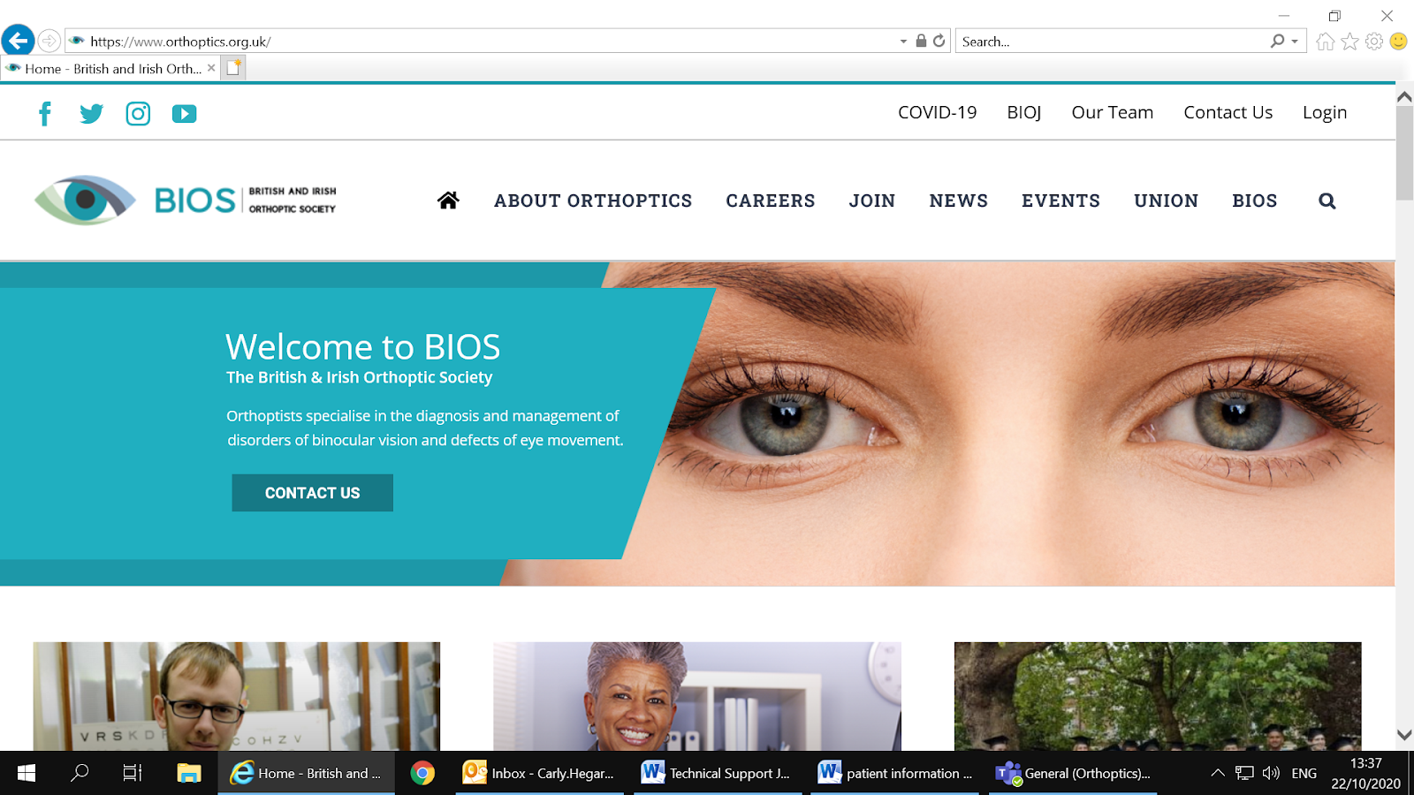
Live Streaming

Dear patient,
Your hospital/Trust is taking part in a project to live stream orthoptic assessments for educational purposes. Please read the information below to allow you to decide if you would like to volunteer for your orthoptic consultation to be live streamed.
Participation is completely voluntary, and your care will not alter if you do not want to take part.
Qualified orthoptists in the UK must complete a degree in Orthoptics at a University. Approximately one third of the course is spent on clinical placements at hospitals across the country, allowing students to develop clinical skills and gain exposure to real patients. These clinical placements are a core part of the degree, however due to the COVID-19 pandemic many students have missed out on placement opportunities. This project is intended to support these students.
The British and Irish Orthoptic Society (BIOS - our professional body) has been awarded funding to purchase some Hololens2 devices. These are cameras worn on the head which your orthoptist will wear the Hololens2 during your assessment. The consultation will be live streamed to students studying Orthoptics at one or more Universities across the UK (University of Sheffield, University of Liverpool, Glasgow Caledonian University, and University College London).
The students will be able to see and hear you, but you will not be able to see and hear them and they will not be interacting with you or the orthoptist treating you. These students have undertaken Data Security Awareness Training and will adhere to the principles of patient confidentiality.
The video of your assessment will mainly show your face and eyes, focusing on results of the eye tests. During the consultation information relevant to the diagnosis and management of your eye condition may be discussed, this will include birth history, previous medical history (including medications) and details about your previous eye health and symptoms. It is occasionally relevant to consider a patients’ occupation and driving status in relation to their visual symptoms and treatments – therefore this may be discussed.

Details such as your name, address, date of birth, NHS number or Hospital Number will not be included on the recording.
Your participation is voluntary and that I am free to withdraw at any time during the assessment by making the clinician aware. Choosing to withdraw from the project will not affect your care.
If you have any further questions about this project, please contact the Lead Clinical Tutor for the project at your email.

You may receive a phone call from an orthoptist in the days before your appointment to ask if you have decided to participate or not, and discuss any questions you may have.

If you decide you would like to be involved – please sign the enclosed consent form and bring it to your appointment.

Thank you for considering this information.

Kind regards,

Your name and role

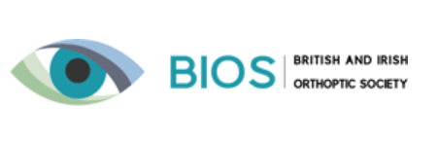
Recording assessments
Your Trust Logo here

Dear patient,
Your hospital/Trust is taking part in a project to video record orthoptic assessments for educational purposes. Please read the information below to allow you to decide if you would like to volunteer for your orthoptic consultation to be filmed.
Participation is completely voluntary, and your care will not alter if you do not want to take part.
Qualified orthoptists in the UK must complete a degree in Orthoptics at a University. Approximately one third of the course is spent on clinical placements at hospitals across the country, allowing students to develop clinical skills and gain exposure to real patients. These clinical placements are a core part of the degree, however due to the COVID-19 pandemic many students have missed out on placement opportunities. This project is intended to support these students.
The British and Irish Orthoptic Society (BIOS - our professional body) has been awarded funding to purchase some Hololens2 devices. These are cameras worn on the head which your orthoptist will use to film your orthoptic assessment.
Once the recording has been made, it may be edited, and then uploaded to a learning resource library on an area of the BIOS website (www.orthoptics.org.uk) which is only accessible to HCPC registered orthoptists and orthoptic students. The resource library will be password protected, and the activity of its users will be monitored. Your recording will not be used anywhere else.
The video of your assessment will mainly show their face and eyes, focusing on results of the eye tests. During the consultation information relevant to the diagnosis and management of your eye condition may be discussed, this will include birth history, previous medical history (including medications) and details about your previous eye health and symptoms.

Details such as your name, address, date of birth, NHS number or Hospital Number will not be included on the recording.
Your participation is voluntary and you are free to withdraw at any time during the assessment by making the clinician aware. Choosing to withdraw from the project will not affect your care.
If you have any further questions about this project, please contact the Lead Clinical Tutor for the project at your email.

You may receive a phone call from an orthoptist in the days before your appointment to discuss your participation and answer any questions you may have.

If you decide you would like to participate, please sign the enclosed consent form and bring it to your appointment.

Thank you for considering this information.

Kind regards,

Your name and role

Appendix K – Patient Information Leaflets (Paediatrics)

Dear ________________

At this hospital we have some new special cameras that record eye tests! These cameras are like goggles that the Orthoptist (the person who does your eye test) wears on their head. It is called the Hololens2.
The video is to help students who are learning all about eyes.
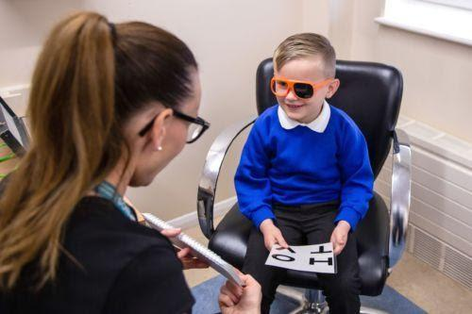
We would like to know if we can make a video of you having your eyes tested using the new camera.
Your eye test will be the same as normal, you will look at some letters, pictures and lights and maybe try on some coloured glasses!
It doesn’t matter at all if you would not like to be in an eye test video – just tell the person who looks after you.
Thank you for reading this – see you soon for your eye test!
If you decide we can make a video of your eye test - please write your name in the box below:
You can make a video of my eye test today and show it to students to help them learn.
Name: __________________________________________
Date: _____________

Live Streaming

Your Trust Logo here

Dear parent/guardian,
Your hospital/Trust is taking part in a project to live stream orthoptic assessments for educational purposes. Please read the information below to allow you to decide if you would like to volunteer for your child’s orthoptic consultation to be live streamed.
Participation is completely voluntary, and your child’s care will not alter if you do not want to take part.
Qualified orthoptists in the UK must complete a degree in Orthoptics at a University. Approximately one third of the course is spent on clinical placements at hospitals across the country, allowing students to develop clinical skills and gain exposure to real patients. These clinical placements are a core part of the degree, however due to the COVID-19 pandemic many students have missed out on placement opportunities. This project is intended to support these students.
The British and Irish Orthoptic Society (BIOS - our professional body) has been awarded funding to purchase some Hololens2 devices. These are cameras worn on the head which your orthoptist will wear the Hololens2 during your child’s assessment. The consultation will be live streamed to students studying Orthoptics at one or more Universities across the UK (Glasgow Caledonian University, University of Sheffield, University of Liverpool, and University College London).
The students will be able to see and hear the patient, but the patient will not be able to see and hear them. All orthoptic students have undertaken Data Security Awareness Training and will adhere to the principles of patient confidentiality.
The video of your assessment will mainly show your child’s face and eyes, focusing on results of the eye tests. During the consultation information relevant to the diagnosis and management of your child’s eye condition may be discussed, this will include birth history, previous medical history (including medications) and details about previous eye health.

Details such as your child’s name, address, date of birth, NHS number or Hospital Number will not be included on the recording.
Your participation is voluntary and you are free to withdraw at any time during the assessment by making the clinician aware. Choosing to withdraw from the project will not affect your child’s care.
If you have any further questions about this project, please contact the Lead Clinical Tutor for the project at your email.

You may receive a phone call from an orthoptist in the days before your appointment to answer any questions you may have and confirm your child’s participation.

If you decide you would like your child to take part – please sign the enclosed consent form and bring it to your appointment.

Thank you for considering this information.

Kind regards,

Your name and role

Recording Assessments

/Dear parent/guardian,
Your hospital/Trust is taking part in a project to video record orthoptic assessments for educational purposes. Please read the information below to allow you to decide if you would like to volunteer for your child’s orthoptic consultation to be filmed.
Participation is completely voluntary, and your child’s care will not alter if you do not want to take part.
Qualified orthoptists in the UK must complete a degree in Orthoptics at a University. Approximately one third of the course is spent on clinical placements at hospitals across the country, allowing students to develop clinical skills and gain exposure to real patients. These clinical placements are a core part of the degree, however due to the COVID-19 pandemic many students have missed out on placement opportunities. This project is intended to support these students.
The British and Irish Orthoptic Society (BIOS - our professional body) has been awarded funding to purchase some Hololens2 devices. These are cameras worn on the head which your orthoptist will use to film your child’s orthoptic assessment.
Once the recording has been made, it may be edited, and then uploaded to a learning resource library on an area of the BIOS website (www.orthoptics.org.uk) which is only accessible to HCPC registered orthoptists and orthoptic students. The resource library will be password protected, and the activity of its users will be monitored. Your child’s recording will not be used anywhere else.
The video of your child’s assessment will mainly show their face and eyes, focusing on results of the eye tests. During the consultation information relevant to the diagnosis and management of your eye condition may be discussed, this will include birth history, previous medical history (including medications) and details about your child’s previous eye health and symptoms.

Details such as your child’s name, address, date of birth, NHS number or Hospital Number will not be included on the recording.
Your child’s participation is voluntary and you/they are free to withdraw at any time during the assessment by making the clinician aware. Choosing to withdraw from the project will not affect your child’s care.
A child-friendly information leaflet is available – please ask your orthoptist if you have not received this.
If you have any further questions about this project, please contact the Lead Clinical Tutor for the project at your email.

You may receive a phone call from an orthoptist in the days before your appointment to discuss your child’s participation and answer any questions you/they may have.

If you decide your child can participate, please sign the enclosed consent form and bring it to your appointment.

Thank you for considering this information.

Kind regards,

Your name and role

Appendix L - Consent forms (Adults)

Please select the appropriate consent form/s for your approved workflow ie. Live streaming/recording.

As per NHS policy the “adult consent” forms can be used from 16years, only the patient is required to sign this form (except in circumstances when the patient is not deemed competent.) Such patients may not be suitable for video consultation - although if they are accompanied by a parent this can be considered on an individual basis and parents can sign the “paediatric consent” where appropriate.

For children 15years and under – parent/guardians must give written consent for recording. If the child wishes to also sign a consent form they can sign the “adult consent” or sign on the paediatric PIL (whichever is appropriate to their reading age) in addition.

Live Streaming
//

Clinical Placement Expansion Project (CPEP) Consent Form – Live stream of orthoptic assessment
Patient name:
Date of birth:
Telephone/Email:
Date of assessment:

□ I have been given an information sheet explaining how my orthoptic assessment will be livestreamed and the purpose of this project.
□ I agree to my orthoptic consultation and assessment being live streamed to orthoptic students at the University of Liverpool, University of Sheffield, Glasgow Caledonian University, and University College London, and the University lecturers. These students have undertaken Data Security Awareness Training and will adhere to the principles of patient confidentiality.
□ I understand that during the consultation, information relevant to the diagnosis and management of my eye condition may be discussed. This may include birth history, previous medical history (including medications), details about your previous eye health and symptoms. It is often relevant to consider a patients’ occupation and driving status in relation to their visual symptoms and treatments, and this too may be discussed.
□ I understand that my participation is voluntary and that I am free to withdraw at any time during the assessment by letting the clinician know. Choosing to withdraw from the project will not affect my care.
□ I consent for my orthoptic consultation to be recorded and the video uploaded to the BIOS learning resource library so it may be used for future teaching sessions (separate video recording consent form required)

Statement of Your Consent:

I have read the above description of this initiative and all my questions have been answered to my satisfaction. I voluntarily agree to take part in this project. I understand I will receive a copy of this consent form.

Please ensure the above checkboxes have been ticked, and sign below to show that you agree to and understand the above statement.
Name (printed): _________________________________________________________________
Signature: _______________________________________________________________________
Date: ___________________

Recording Assessments
//

Clinical Placement Expansion Project (CPEP) Consent Form
The following details will be made available to BIOS (British and Irish Orthoptic Society) administrative staff so that your video can be identified and taken down in the event that you withdraw your consent. BIOS will store the data contained on this form in compliance with the EU General Data Protection Regulation Act (2018). For further information on the security features that will be present to secure this data, please visit www.orthoptics.org.uk/security (TBC).
□ I consent to my name, date of birth, and contact details being stored securely by BIOS.
Video ID number (to be completed by the clinician):
Patient name:
Date of birth:
Telephone/Email:
□ I hereby agree to my picture, voice and/or video recording being used by your Trust and the British and Irish Orthoptic Society (BIOS) for clinical teaching purposes. I understand the picture, voice and/or video recording will be available to UK registered orthoptists and orthoptic students through an online resource library, managed by BIOS.
□ I have been given an information sheet explaining how my images or videos will be used.
□ I understand that the online resource library will be housed in an area of the BIOS website which will only be available to registered members of British and Irish Orthoptic Society (BIOS). The resource library will be password protected, and the activity of its users will be monitored. These recordings will be reviewed every two years and will be removed if the content is no longer relevant.
□ I understand that the recordings made today will be hosted on Vimeo (a video hosting platform with servers inside and outside of the EU), but that they will not be searchable or downloadable. My personal identifiable information will not be attached to the video and this will be stored separately in the secure administrative area of the BIOS website.
□ I understand that my participation is voluntary and that I am free to withdraw at any time by informing BIOS at the contact details provided on the information sheet below. If you withdraw your consent, any recordings that have been made of you will be removed from Vimeo and the BIOS resource library, and your identifiable information (such as name and contact details) will be removed from BIOS records.

Statement of Your Consent:

I have read the above description of this initiative and all my questions have been answered to my satisfaction. I voluntarily agree to take part in this project. I understand I will receive a copy of this consent form.

Please ensure the above checkboxes have been ticked, and sign below to show that you agree to and understand the above statement.
Name (printed): _____________________________________________
Signature: ___________________________________________
Date: ___________________

If you decide you would like to withdraw your consent and have the images made today removed from the resource library, please contact visit www.orthoptics.org.uk/remove-my-recording (TBC) and fill in the request form. Alternatively, you can contact BIOS on 0121 728 5633, or email bios@orthoptics.org.uk.

Appendix M - Consent forms (Paeds)
/ Live Streaming
/
Your Trust’s logo here

Clinical Placement Expansion Project (CPEP) Consent Form – Live stream of orthoptic assessment (paediatric version)
Patient name:
Patient date of birth:
Parent/guardian phone number or email address:
Date of assessment:

□ I have been given an information sheet explaining how my child’s orthoptic assessment will be livestreamed, and the purpose of this project.
□ I agree to my child’s orthoptic consultation and assessment being live streamed to orthoptic students at the University of Liverpool, University of Sheffield, Glasgow Caledonian University, and University College London, and the University lecturers. These students have undertaken Data Security Awareness Training and will adhere to the principles of patient confidentiality.
□ I understand that during the consultation, information relevant to the diagnosis and management of my child’s eye condition may be discussed. This may include birth history, previous medical history (including medications), and details about previous eye health and symptoms.
□ I agree to being included in the livestream if I am present during the consultation.
□ I understand that my child’s participation is voluntary and that they are free to withdraw at any time during the assessment. Choosing to withdraw from the project will not affect my child’s care.
□ I consent for my child’s orthoptic consultation to be recorded and the video uploaded to the BIOS learning resource library so it may be used for future teaching sessions (separate video recording consent form required)
Statement of consent on behalf of the patient:

I have read the above description of this initiative and all my questions have been answered to my satisfaction. I voluntarily agree to my child taking part in this project. I understand I will receive a copy of this consent form.

Please ensure the above checkboxes have been ticked, and sign below to show that you agree to and understand the above statement.
Name of patient (printed):
___________________________________________________________________________________
Name of parent/guardian and relationship to the patient (printed):
___________________________________________________________________________________
Signature of parent/guardian:
___________________________________________________________________________________
Date:
___________________

/Recording Assessments
Your Trust’s logo here
/

Clinical Placement Expansion Project (CPEP) Consent Form – Paediatric version
The following details will be made available to BIOS (British and Irish Orthoptic Society) administrative staff so that your child’s video can be identified and taken down in the event that they withdraw their consent. BIOS will store the data contained on this form in compliance with the EU General Data Protection Regulation Act (2018). For further information on the security features that will be present to secure this data, please visit www.orthoptics.org.uk/security (TBC).
□ I consent to my child’s name, date of birth, and my contact details being stored securely by BIOS.
Video ID number (to be completed by the clinician):
Patient name:
Patient date of birth:
Parent/guardian phone or email:

□ I hereby agree to my child’s picture, voice and/or video recording being used by your Trust and the British and Irish Orthoptic Society (BIOS) for clinical teaching purposes. I understand the picture, voice and/or video recording will be available to UK registered orthoptists and orthoptic students through an online resource library, managed by BIOS.
□ I have been given an information sheet explaining how my child’s images or videos will be used.
□ I understand that the online resource library will be housed in an area of the BIOS website which will only be available to registered members of British and Irish Orthoptic Society (BIOS). The resource library will be password protected, and the activity of its users will be monitored. These recordings will be reviewed every two years and will be removed if the content is no longer relevant.
□ I understand that the recordings made today will be hosted on Vimeo (a video hosting platform with servers inside and outside of the EU), but that they will not be searchable or downloadable. My child’s personal identifiable information will not be attached to the video and this will be stored separately in the secure administrative area of the BIOS website.
□ I agree to being included in the video if I am present during the consultation.
□ I understand that my child’s participation is voluntary and that they are free to withdraw at any time by informing BIOS at the contact details provided on the information sheet below. If they withdraw your consent, any recordings that have been made of them will be removed from Vimeo and the BIOS resource library, and their identifiable information (such as name and contact details) will be removed from BIOS records.

Statement of Your Consent:

I have read the above description of this initiative and all my questions have been answered to my satisfaction. I voluntarily agree for my child to take part in this project. I understand I will receive a copy of this consent form.

Please ensure the above checkboxes have been ticked, and sign below to show that you agree to and understand the above statement.

Signature: ___________________________________________
Name of parent/guardian (printed): _____________________________________________
Relationship to patient: __________________________________
Date: ___________________

If you decide you would like to withdraw your consent and have the images made today removed from the resource library, please contact visit www.orthoptics.org.uk/remove-my-recording (TBC) and fill in the request form. Alternatively, you can contact BIOS on 0121 728 5633, or email bios@orthoptics.org.uk.

appendix N – Sharing Agreement

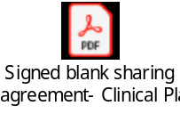

Appendix O – Security Design

14. BIOS PORTAL SECURITY

14.1 1.0 INTRODUCTION
To ensure Site clinical leads can get their Trust’s approval of the BIOS Portal, it is essential that we implement security standards, as close as possible to NHS approved standards. This document will outline the design decision discussed with both BIOS and Douglass Digital and will be shared with the Project Board for approval.

14.2 2.0 ACCOUNT AUTHORISATION
At present, anyone can request access a BIOS membership (and therefore use of the Members Area of the website), and no measures are taken to determine whether they are a legitimate member. To give clinicians and students access to the BIOS portal, a more robust process needs to be in place to ensure only active Orthoptic students and clinicians (who have completed their annual, mandatory Data Security & Protection Training) can gain access to the portal.
(a) 2.1 STUDENTS
(i) FOR STUDENTS TO GAIN ACCESS TO THE PORTAL, THE UNIVERSITY WILL BE REQUIRED TO COMPLETE DATA SECURITY & PROTECTION TRAINING EVERY YEAR WITH THEIR STUDENTS. TO ENABLE THIS, EACH STUDENT MUST REGISTER WITH HTTP://WWW.E-LFH.ORG.UK(E-LEARNING FOR HEALTHCARE FROM HEALTH EDUCATION ENGLAND) AND COMPLETE THE DATA SECURITY AWARENESS LEVEL 1 MODULE. ONCE THE STUDENT HAS PASSED THE ASSESSMENT, THEY WILL RECEIVE A DIGITAL CERTIFICATE, WHICH THEY ARE TO EMAIL TO THEIR UNIVERSITY PLACEMENT LEAD. THE UNIVERSITY WILL BE RESPONSIBLE FOR KEEPING A RECORD OF EACH STUDENT WHO HAS SUCCESSFULLY COMPLETED THE E-LEARNING MODULE. ONCE THE COHORT HAS BEEN SIGNED OFF, THE INFORMATION CAN BE SENT TO BIOS WHO WILL AUTHORISE FOR THE STUDENT TO HAVE ACCESS TO THE PORTAL FOR ONE YEAR. AFTER THE YEAR HAS LAPSED, THE UNIVERSITY WILL NEED TO REPEAT THE ABOVE PROCESS IN ORDER FOR STUDENTS TO REGAIN ACCESS TO THE BIOS PORTAL FOR A FURTHER YEAR. PLEASE REFER TO APPENDIX A FOR FURTHER DETAILS OF THE PROPOSED WORKFLOWS FOR STUDENTS TO REQUEST ACCESS TO THE BIOS PORTAL.
(ii)
(iii) 2.1.1 CHANGES REQUIRED TO ENABLE THIS PROCESS
• The Universities to take ownership of the students who are to be signed off for access to the BIOS Portal.
• The students are to complete a Data Security Awareness online module from Health Education England’s e-Learning for Healthcare website to ensure their understanding is in line with the NHS security requirements.
• The BIOS administration team will need to permit each student access to the BIOS Portal functionality and set the account to lapse after one year.
• Any students who require an extension to their course end date will need to continue to complete the yearly Data Security Awareness module and request the extension via their University placement lead who can approve via BIOS.
• Update student BIOS account registration to include a drop-down field for the date the course started, and the date the expected course end date.

(b) 2.2 UNIVERSITY LECTURERS/CLINICIANS

As University Lecturers/Clinicians already receive Data Awareness training as part of their employment contract, their access to the BIOS Portal will be able to roll on year on year. Please refer to Appendix B for further details of the proposed workflows for clinicians/university lecturers to request access to the BIOS Portal.
• Any clinicians requesting to become a member of BIOS will follow the usual BIOS process, however any clinician requesting specific access to the BIOS Portal, will need to be checked against the HCPC/Republic of Ireland equivalent, to ensure they are registered before access can be given – Process has been reviewed with Rich Huzzey from Bios who confirmed this would be possible.
• Once the clinician’s registration has been confirmed, the user will be placed into the BIOS Portal group, which will give their existing login access to the BIOS Portal. From this user passwords and account timeouts will be updated in line with the new security policy.
• All NHS clinicians receive annual Data Protection & Security training as part of their NHS mandatory training programme.
• All University lecturers complete annual Data Awareness Training via the University mandatory training programme.
• Any clinicians who work for a private practice will be required to complete annual Data Awareness Training for their profession body.
• BIOS Administrators are required to complete annual Data Security Training as part of the BDA (British Dietetic Association).
(i)
(ii) 1.2.1 CHANGES REQUIRED TO ENABLE THIS PROCESS
BIOS will only grant Clinicians access to the BIOS Portal once a member has been checked against the HCPC/Republic of Ireland register.
05/05/2021 – Douglass Digital to investigate whether a CSV file can be created, for Universities to populate with the details of the students who have completed their yearly mandatory training. This file can then be forwarded to BIOS, for the students’ names to be batch uploaded into the BIOS Portal group. This would save BIOS a lot of effort and time, manually adding each student into group, every year.
14.3 3.0 LEAVERS PROCESS
BIOS currently receive a monthly list of Clinicians whose registration has been ceased as a result of being struck-off the HCPC register. Using this information, it will be the responsibility of the BIOS to ensure that these users are immediately removed from the BIOS Portal with immediate effect.

BIOS has confirmed that at present there is no way of identifying any clinicians who have retired, left the profession, or moved overseas, this part of the process is reliant on the clinician notifying BIOS so their BIOS membership fee can be updated. There is the chance the Clinician may choose to continue paying the membership fee after leaving the profession and would therefore still have access to the BIOS Portal. However, as the account would become inactive after an agreed period, the user would be required to unlock the account answering set security questions on whether they are still actively working in the profession. Any users who state they are no longer working in the profession, would appear on a regular report to the BIOS Administrator, for their access to the BIOS Portal to be removed.

*This risk will be reviewed further with BIOS and Douglass Digital to see if any further functionality/processes can be put in place to reduce this risk.

14.4 4.0 ACCOUNT INACTIVITY
A decision needs to be made on the length of time an account should be suspended for any account inactivity and how the user can regain access to the account once access is required. The project team recommends that once the account has been inactive for ** days, the user will be able to regain access via the BIOS website by answering a set list of security questions to unlock the account. This process will also affect any staff who take extended leave i.e., Maternity Leave, Long Term Sickness or Career Breaks.

The NHS recommend after 30 days of inactivity with a clinical information system, the account should be automatically disabled and the account description should be updated with details of the date the account was disabled.
29/04/21 - This requirement was approved by the Project Board on the understanding that unlocking accounts is made as simple as possible for users to complete themselves i.e. use of security questions.

In regards to the decision on the period of time that accounts should be locked, the project board has requested that this decision is reviewed with BIOS.

05/05/21 - Further to this, BIOS have further discussed that they would like to review how easy it will be for users to unlock accounts themselves before making this decision. Douglass Digital will test this functionality and provide a demonstration so that a decision can be made.

Douglass Digital confirmed they will test whether additional questions can be added to the unlock account page and feedback the results.

14.5 5.0 PASSWORDS/ACCOUNT LOCKS
The Project Team recommend that when a clinician/student is granted access to the BIOS Portal, their account security is updated in line with the latest NHS Mail Password Policy (released in Spring 2019) which adheres to the National Cyber Security Centre (NCSC) guidelines. Any BIOS accounts that are granted access to the BIOS Portal will be required to adhere to the following standards:
• Minimum length 10 characters without requiring a mix of character types
• Maximum password age of 365 days
• Not matching previous 4 passwords
• Users will have the added ability to reset their passwords at any time via the BIOS Portal.
• Accounts will be locked after 3 failed attempts
• Accounts can be unlocked via the BIOS Portal by answering security questions
29/04/21 – The stricter password policy was reviewed with the Project Board, who approved this feature to prevent the need for a site wide stricter security policy.

The Project Board has decided not to pursue the use of 2 factor authentication, due to connectivity issues within Trusts and as mobile phones are not allowed in specific areas of the trust. Therefore, it was deemed that this security feature could prevent users gaining access to the BIOS Portal.

The Project Board agreed to for users accounts to be locked after 5 failed passwords. Douglass Digital confirmed the account will be locked for increasing periods of time to prevent brute force attempts at gaining access to the BIOS Portal.

05/05/2021 – Douglass Digital confirmed that a stricter password policy could be assigned to the BIOS Portal group, however we still need confirmation as to whether all users will be affected by the increased character length. Douglass Digital to test and confirm.

Douglass Digital to confirm if we can set our own questions on the ‘Unlock Account’ page.

Further to this Douglass Digital confirmed that once the BIOS administrator has moved a user out of the BIOS Portal group for not keeping up with their BIOS payments, the user will not be able to re-gain access to the portal via this unlock feature.

14.6 6.0 AUDIT TRAILS
To be able to track a user’s activity within the BIOS Portal, it is necessary to have system cookies enabled. At present this functionality has not been included in the web package procured from Douglass Digital (DD). DD has explained that this this functionality can be added at the following cost:
“It will be 3 extra days of development work to build the cookie to track the user and create a report in the system so you can see which users access which pages in the portal over a date range.

£595 + VAT per day = £1,785.00 + VAT”

The decision to proceed with this functionality has been approved at the Project Board on 29th April 2021.
14.7 7.0 PENETRATION TESTING
Penetration Testing is a type of Security Testing used to uncover vulnerabilities, threats and risks that an attacker could exploit in software applications, networks or web applications. Common vulnerabilities include design errors, configuration errors and software bugs.

Nottingham University Hospital have requested evidence of penetration testing. Penetration testing cannot be completed until the BIOS Portal is fully built. Douglass Digital have recommended using a company called Bullet Proof, who can take 3 to 5 days to complete testing at approximately £1100 per day. Douglass Digital recommends penetration testing should be completed yearly to ensure vulnerabilities are proactively identified.

29/04/21 - The Project Board were not keen to pursue this at such an early stage in the development. However, the decision will be reviewed in July 2021 once the Portal has been built and the board has a better understand of Trusts requirements.

14.8 8.0 REPORTS
To date, the type of reports that need to be available to the BIOS Administrator are as follows:
• Daily/Weekly/Monthly report of failed login attempts to the BIOS Portal,
• Daily/Weekly/Monthly report of failed login attempts to the BIOS Portal who are no longer working as an active Orthoptist/Lecturer.
• Monthly report of accounts that have been locked due to inactivity,
• Ability to download a list of the content accessed by individual users (time and date)
• Ability to identify a list of the users who have accessed the restricted admin area of the BIOS Portal, the content that has been accessed and the time and date,
• Visibility of the users who have an active signed declaration,
• Ability to identify Students with active BIOS accounts by University, the year they commenced and the year they are due to graduate and the date their BIOS account is due to terminate.
• Ability to identify clinicians and the trust they work for,
• A list of the users assigned to each Role Based Access Control.
Student Access
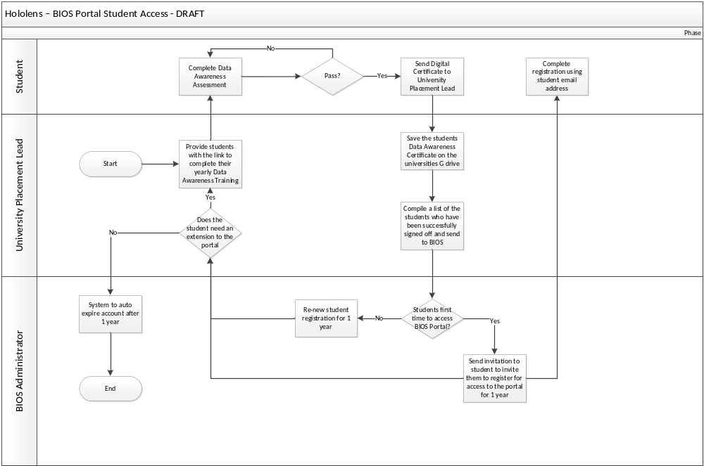

University Lecturer Access

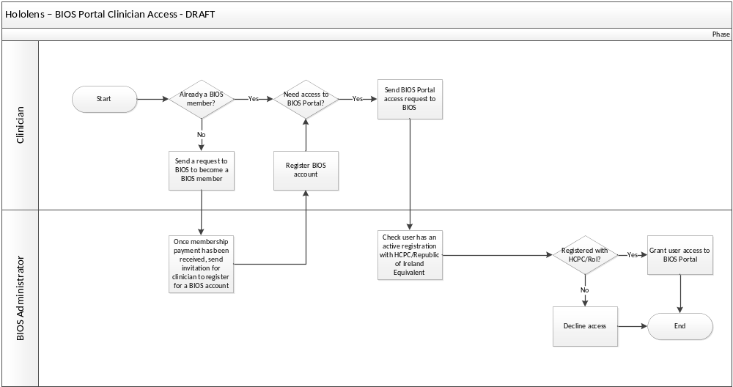

Appendix P- Frequently Asked Questions

- Who is the data controller for the videos? BIOS
- Does BIOS have a data processing agreement with Vimeo? BIOS do not have a data processing agreement in place with Vimeo.
- Can the videos be encrypted on the Hololens? HoloLens 2 enables Bitlocker Device Encryption (BDE) by default to protect data from any unauthorized physical access to the device. Always evolving to meet the needs of the future, Microsoft continues to invest and enhance this technology. For further information please see Encryption and Data Protection | Microsoft Docs
- Is there a data sharing agreement in place between Trusts and BIOS? We are in the process of reviewing a Data Sharing Agreement between Leeds University Hospital and BIOS, once this document is signed a copy will be made available in the Approval Guide.
- Is there a regular penetration test for security undertaken by Douglas digital, do you have evidence of this occurring? This was discussed at project board and at this point in the project the board will not be authorising penetration testing of the BIOS Portal. The aim is for the BIOS Portal to be built by 2nd July, so penetration testing will be re-considered at the July project board.
- Would the students be using personal devices to access the videos? Potentially, Yes.
- BIOS password – what is the minimum character requirement for members to access the BIOS portal? 10 Characters and the password will be reset yearly.
- If the Hololens were to fail can data be easily deleted from the device? Still waiting for Insight to provide an answer to this question.
- Application of Hololens/Remote Assist licences to the central tenant of N365 – Insight confirmed that this is not yet available and, currently, there is no timeline when it will be. The only option is to host in a private tenant.
- Does the Hololens2 consist of medical grade plastic to ensure it complies with NHS infection control requirements? Insight don’t believe that a specific definition of ‘medical grade plastics’ actually exists so found it difficult to answer this question. They did confirm that that the device can be cleaned easily (see Q.3 below). Furthermore, they confirmed that Alder Hey and Imperial use Hololens devices in a theatre setting and to do so must believe that the device is safe to use.
- How easily can the Hololens2 be cleaned? This link provides details of how to clean the product: https://docs.microsoft.com/en-us/hololens/hololens2-maintenance
- Can the Hololens be worn under a visor? We can confirm that Imperial use the Hololens device with a visor.
- If we registered the Hololens at each individual trust, would the videos be stored in different location? If so, would there be a way of automatically sharing these video’s between trusts and universities via the Teams cloud? Video is stored according to the Trust’s Teams configuration – so if a user logs on to a particular Trust domain, that is where the content will sit and others outside that domain would not be able to access directly – you would need to look at exporting the video to redistribute (with appropriate governance). We can help design that process for you.
- If all devices were registered with BIOS would this enable centralised storage of the video’s? Subject to being able to access the BIOS domain from a particular Trust site, this should be possible – there are local Trust IT issues that need to be addressed, however?
- Can the Team’s cloud be set up to only allow streaming of the video rather than the ability to download? There are device configuration options to set up according to your requirements
- Is there a way patient consent can be stored with the video? Need to explore the detail of this further before commenting
- Do you have any experience of similar setups from other organisations? Cross domain working is a challenge that has come up from a number of Trusts (not just for HoloLens, but for Teams in general) & there isn’t a standard answer – there is high degree of dependency on Trust IT and how things have been set up (and also whether each Trust is using a local tenant or national). Our Mixed Reality consultants are also expert Teams consultants and work extensively across the NHS. We explore how the domain access needs to be configured during the implementation phase, inc. issues of federated access, guest access etc. This does need to be planned and designed in conjunction with the Trust IT though

Appendix Q – Waiting Room Posters

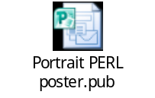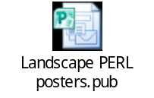

Appendix R – Best Practice Guidance
Livestreaming/recorded orthoptic assessments - Best practice guidance
Student Participants
The opportunity to view these orthoptic assessments (either live or on the Placement Expansion Resource Area (PERL)) has been provided to you to enhance your learning- please ensure you are respectful and professional as you interact with them as you would be on clinical placement.
You will not be able to participate in viewing live/recorded orthoptic assessments if you have not undertaken the annual Data and Security Mandatory Training.
You are required to agree to the following disclaimer in order to view these consultations:
I understand, accept and agree to be bound by the requirements of the Data Protection Act (2018) and the principle of confidentiality of patient records and patient data. I will not make copies (including photographs, recording or screen-grabs) of the images or recordings of patients during the live stream consultation or within the BIOS PERL.
I will not share or distribute the Microsoft teams meeting information to anyone else.
I will not share or distribute the images on the BIOS PERL with anyone else. I confirm that I am using my own log-in details, that I have completed the e-Learning for Healthcare Data Security Awareness online module, and I understand that my activity within the PERL will be monitored and analysed using cookies.

Signature :_________________________________________________ Date: ________________________
Print name: _________________________________________________
- Please adhere to the following NHS best practice guidance:
- You should not share the invite with anyone else, only people invited by the host should attend.
- You should join the consultation from a private space, and the screen must not be visible to anyone else
- Your camera and microphone must remain off throughout the consultation.
- Your Teams username will be visible, so make sure this is appropriate and professional.
- Join the meeting on time.
- Do not record the meeting on your personal device, or take photos or screen-grabs of at any time.
- Use the chat box to ask any questions to the Orthoptist performing the consultation.

Recording Orthoptic assessments - Best practice guidance
Clinical Tutor Participants
The initial process:
- Orthoptists may decide to look ahead and review patient notes to see if they would be suitable for a recorded video assessment. After identifying suitable patients, post a patient information leaflet and consent form for them to review and bring with them to their appointment.
- If a patient attends as an extra and you think they would be suitable for video recording, provide them with an information leaflet and discuss the process with them, having them sign a consent form if they agree.
- Ensure the patient has had enough time to consider their voluntary participation, and ask questions as per your trust protocols.
Patients who may not be suitable for livestreaming include:
- Patients who cannot give informed consent (adults with learning difficulties, dementia, stroke patients with communication difficulties, patients who don’t speak English when no interpreter if present)
- We do not advise using telephone/online translation services for recorded assessments. Most importantly, it will be difficult for the patient to give their informed consent this way, and also will present difficulties in giving instructions to the patient via the phone translator if the orthoptist is wearing the Hololens headset
- If at interpreter is present, then you should allow the interpreter to run through the information sheet and consent form with them and give them time to answer any questions before starting the consultation. To make the recording confidential for the interpreter, they should stay off screen for the duration of the assessment
- If family members are present for the consultation, they should also be kept out of the view of the orthoptist.
- If a parent or guardian will be visible during the consultation, they will need to sign a separate consent form.
On the day of the recorded assessment:
- Set up and test the Hololens2, and ensure it is fully charged.
- When the patient arrives, scan a copy of their signed consent form to a local hard drive.
- Bring the patient into the room and before recording commences ensure the patient has read the Patient Information Leaflet and completed the consent form appropriately. Give them the opportunity to ask any questions.
- Scan the signed consent form to a local hard-drive (this can be done after the assessment if more appropriate)
- Ensure you have explained to the patient that they can decline to provide any information that they do not feel comfortable discussing during the video consultation and that if necessary, these topics may be discussed once the video has been discontinued.
- Begin recording If you wish to describe what you are seeing, or your justification for test selection etc during the assessment then please do. This may be useful for the Lead clinical Tutors when editing the videos, though we may remove the audio when the video is uploaded. Similarly, if you prefer to only talk to the patient throughout this is fine.
Once the recording has been uploaded to the BIOS portal, the Lead Clinical Tutors for the Placement Expansion Project (Elizabeth Lomas and Alice Donnachie) will edit it to a more concise format. Carry out the assessment as you would normally, and time-consuming or irrelevant tests (such as visual acuity in adults) may be edited out for timing reasons.
After the recorded assessment:
- Download the video file from the Holiolens2 to a local Trust computer
- Use the BIOS portal upload page to generate a unique video ID code. Rename the video file with this code before uploading.
- Upload the video file to Vimeo This will be edited before being uploaded to the portal.
- Permanently delete the recording from the Hololens2 and the local computer.
- You will not be notified when the recording has been added to the BIOS portal. If the video is not uploaded, we will contact you to let you know the reason.
During the recorded patient consultation, professional responsibility regarding communication, privacy, dignity and confidentiality must be maintained by the Orthoptist. Please adhere to the following NHS online consultation guidance:
- Ensure that you are in a suitable place for the consultation to happen. Background noise, other persons, visual background can distract from the patient assessment.
- A private space where you will not be overheard, or interrupted, will help to ensure confidentiality. If possible, place a ‘do not disturb’ notice on the door of the consultation room to prevent interruptions.
- Ensure you are familiar with the Hololens2 device, and Microsoft Teams, before the day of the consultation so that time is not wasted setting these up.
- Before starting the consultation, ensure attendees can see and hear you.
- Always introduce yourself to the patient as you would do normally.
- Remove any visual identifiers of the location such as signs or logos.
- Avoid asking the patient anything which may make them identifiable, such as name, date of birth, address. Unless it is directly relevant to the investigation or management of the patient do not ask them to disclose personal details about themselves such as occupation or social history.
- Avoid looking at the patient's paper or electronic records during the live streamed consultation as this will have patient identifiable information attached to it that will be visible to those viewing the consultation. If you wish to show the viewers the notes, make sure the PII (such as name, DOB and address) are fully covered.
- When writing in the patients notes, document clearly that the assessment was live streamed.

Livestreaming Orthoptic assessments - Best practice guidance
Clinical Tutor Participants
The initial process:
- A minimum of 6 weeks before the proposed live-streaming session, the Universities will reach out via the Clinical Tutors Placement group email to request a live-streaming session.
- If you have suitable patients booked during the proposed time (who have not previously opted-out of livestreaming), post out patient information leaflets and consent forms for the patient to review.
- Two weeks before the proposed session, the Orthoptist should contact the patient to discuss the proposal with them, and see if they consent.
- If the patient(s) DO NOT consent, the Orthoptist must contact the University to withdraw from the livestreaming session.
- If the patient(s) DO consent, the Orthoptist must notify the University and send a Microsoft Teams invitation to the University/students for same time and date as the patients(s) appointment.
- If the patient cancels/reschedules the appointment or withdraws their consent, notify the University and cancel the Microsoft Teams meeting as soon as possible. (If there are multiple patients attending the clinic who have consented to livestreaming, this step may not be required as there will likely be another patient whose assessment can be livestreamed instead)
Alternatively – if a suitable patient for livestreaming is identified to be a good learning opportunity and the patient DOES consent, this can be offered to University tutors on an adhoc basis for any student to log in to voluntarily.
If it is possible to record the assessment in addition to live streaming (according to your approved workflows) please do so – to enable as many students as possible to view the consultation.
In this circumstance the site clinical tutor creates a Microsoft teams meeting at the appointment time and shares this with Universities with a short description of the case if available. The Universities can share this with students as appropriate.

Before live streaming commences ensure the patient has read the Patient Information Leaflet and completed the consent form appropriately. Give them the opportunity to ask any questions.

Scan the signed consent form to a local hard-drive.

On the day of the livestreaming session:
- Set up and test the Hololens2, and ensure it is fully charged.
- When the patient arrives, scan a copy of their signed consent form to a local hard drive.
- Five minutes before the scheduled appointment, log in to the Hololens and calibrate the eye-tracker.
- Join the Teams meeting a few minutes early so you have time to get comfortable with the technology.
- At the scheduled meeting time, begin the patients consultation. (Select mute all so you cannot hear /see attendees?)
- Please briefly introduce the consultation to those watching – keep in mind that students at all points of academic study may be watching the consultation. If you can please indicate briefly what aspect of the consultation would be of particular interest to each level (depending on the complexity of the patient) for example – you might expect that a 1st year would find the case history and cover test findings particularly useful, a second year would be able to record and perhaps interpret the OM findings and a 3rd or 4th year critically consider the differential diagnosis and BHTT results for example.
- Attendees should use the chat box to ask any questions. At the end of the consultation, you can review these before the patient leaves, to see if there are any tests you should repeat.
During the live livestreamed patient consultation, professional responsibility regarding communication, privacy, dignity and confidentiality must be maintained by the Orthoptist.
Ensure you have explained to the patient that they can decline to provide any information that they do not feel comfortable discussing during the video consultation and that if necessary these things may be discussed once the video has been discontinued.
- Ensure that you are in a suitable place for the consultation to happen. Background noise, other persons, visual background can distract from the patient assessment.
- A private space where you will not be overheard, or interrupted, will help to ensure confidentiality. If possible, place a ‘do not disturb’ notice on the door of the consultation room to prevent interruptions.
- Ensure you are familiar with the Hololens2 device, and Microsoft Teams, before the day of the consultation so that time is not wasted setting these up.
- Before starting the consultation, ensure attendees can see and hear you.
- Always introduce yourself to the patient as you would do normally.
- Remove any visual identifiers of the location such as signs or logos.
- Avoid asking the patient anything which may make them identifiable, such as, name, date of birth, address. Unless it is directly relevant to the investigation or management of the patient do not ask them to disclose personal details about themselves such as occupation or social history.
- Avoid looking at the patient's paper or electronic records during the live streamed consultation as this will have patient identifiable information attached to it that will be visible to those viewing the consultation. If you wish to show the viewers the notes, make sure the PII (such as name, DOB and address) are fully covered.
- When writing in the patients notes, document clearly that the assessment was live streamed.
- If the connection drops during the live stream, wait for a few minutes for the Teams meeting to resume. If this does not happen after 5 minutes, you can abandon the live stream and continue the patient assessment as normal.
Patients who may not be suitable for livestreaming include:
- Patients who cannot give informed consent (adults with learning difficulties, stroke patients with communication difficulties, patients who don’t speak English when no interpreter if present)
- We do not advise using telephone/online translation services for livestreamed assessments. Most importantly, it will be difficult for the patient to give their informed consent this way, and also will present difficulties in giving instructions to the patient via the phone translator if the orthoptist is wearing the HoloLens headset
- If at interpreter is present, then you should allow the interpreter to run through the information sheet and consent form with them and give them time to answer any questions before starting the consultation. To make the lives-streaming confidential for the interpreter, they should stay off screen for the duration of the assessment
- If family members are present for the consultation, they should also be kept out of the view of the orthoptist.
- If you are live streaming the assessment of a child where it is unavoidable for the parent/guardians face or voice to be included in the video please ensure they are aware of this and fully consented to it.

