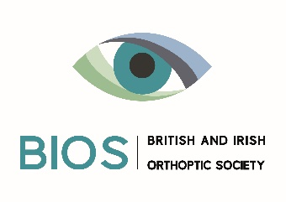
Case Study Template

The purpose of this document is to provide a framework for sharing patient case studies which demonstrate the value of orthoptic services. The information should provide information about the issue the patient was experiencing, the intervention and the outcomes of this. This template outlines some of the key information required to provide an effective and impactful case study, which will be used as part of BIOS’ influencing campaign.

Name of service and location (please include country)
Brief summary of the intervention: What you did? Why you did it? What were you aiming to achieve? Who was it aimed at?
Evidence of Impact: What were the results? Can you evidence the impact of this intervention (qualitative/ quantitative data)? Who has benefited? What has changed? What are the long-term benefits? We are particularly interested in the social and economic of what you did.
Human interest story: Where possible please provide names and direct quotes. Where possible, please supply photographs as jpeg attachments stating who / what the photographs show
Contact details (Please provide the contact details of the person who led this work who could be contacted for further information)
Do you have consent from the patient for their name to be used? (If yes, please provide patient name)
Any other comments

IMPORTANT:
This case study may be used in the wider public domain to promote the profession as part of BIOS’ influencing campaign. Please ensure that you have gained permission from your employer and, where appropriate, the service user(s) if named.
Please return this form to campaigns@orthoptics.org.uk
Thank you for your help in promoting the value of orthoptics.

