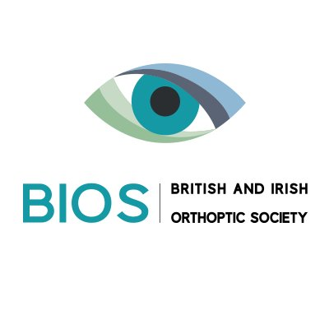
Neuro-Orthoptic CAG Study Day
Friday 2nd November 2018
Governor’s’ Hall St Thomas’ Hospital, Westminster Bridge Road. London.

09.00 - 09:30 | Registration and poster viewing
09:30 - 09:40 | Welcome & Introduction | Jo Adeoye & Liz Tomlin  BIOS Neuro-Orthoptics CAG
09.40 - 10.30 | Obscure cases of diplopia | St Thomas Medical Eye Unit.
10.30 -11.10 |  | Mr Mike Burdon  Consultant Ophthalmologist  University Hospitals Birmingham  President of the RCOph
11.10 - 11:30 | Tea & coffee
11.30 - 12.10 | Three cases I have learnt from | Mr Tim Matthews  Consultant Ophthalmologist  University Hospitals Birmingham
12.10 - 12.40 | Case Presentations | Orthoptist - various
12:40 - 13:30 | lunch and posters
13.30 - 14.10 | Pupils for the Neuro- Orthoptist | Mr Fion Bremner  University College London  Consultant Ophthalmologist
14.10 - 14.40 | Submitted Presentations | Orthoptist - various
14:40 - 15.20 | Diplopia: when to worry | Dr Gordon Plant  Consultant Neurologist  Moorfields Eye Hospital London
15.20 - 15.40 | Tea & coffee
15.40 - 16.20 | Grand rounds cases | Orthoptist - various
16.20 - 16:30 | Closing remarks & Prize giving | Liz Tomlin & Jo Adeoye  BIOS Neuro-Orthoptics CAG

