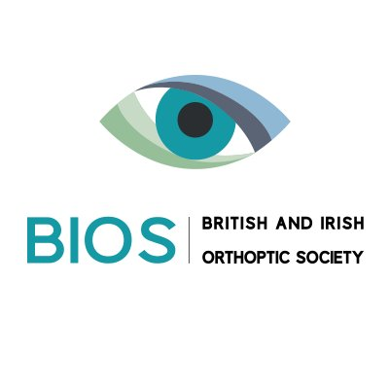
Neuro-Orthoptic CAG Study Day
Friday 2nd November 2018
Governors’ Hall St Thomas’ Hospital, Westminster Bridge Road. London.

Abstract Guidance
Abstracts should be no more than 500 words in length and should give an overview of the topic/ case you intend to present.
Contact: Please email abstracts to Liz Tomlin: Liz.Tomlin@gstt.nhs.uk and Joanne Adeoye: Jadeoye@liverpool.ac.uk
Deadlines:
Abstract submissions should be received by Midnight Monday 8th October 2018
Posters should be printed and brought along on the day
Presentations should be emailed 48hours in advance

Poster:
Title
Purpose/ Aim
Method
Results
Conclusion

Case Presentation (8mins presentation + 2mins discussion):
Title
Diagnosis/ Differential Diagnosis
Investigations
Conclusion

Grand Rounds (8mins presentation + 2mins discussion) :
Title
Brief details of case/ point of interest:

